General Questions: 2

1) What is Spring framework? 2

2) Advantages of Spring? 3

3) Spring module? 3

4) Spring version 4

5) Design patterns used in Spring? 6

6) Spring container? 10

7) What is dependency injection? 11

8) In how many ways can Dependency Injection be done? 11

9) Which injection is better? 12

SPRING CORE 12

10) What is DI? 12

11) Constructor DI vs Setter DI? 13

12) Spring IOC container? 14

13) IOC in Spring? beanFactory vs ApplicationFactory? 14

14) Types of IOC container? 15

15) Additional capability of Application context? 16

16) How to instantiate a Spring IOC container? 17

17) What is spring bean? 17

18) What is bean wiring? 17

19) Explain Spring dependency injection with XML config? 18

20) Explain spring DI using annotation. 21

21) Explain configuration using java Config? 24

22) What are the bean scopes? 27

23) How Spring manages singleton bean with prototype bean dependencies? 29

24) How to create a custom scope? 29

25) Bean Lifecycle? 29

26) Explain Life cycle callback methods of Bean. 31

27) Sequence of lifecycle methods? 34

28) Example of beanPostProcessor? 35

29) BeanPostProcessor? 36

30) How to register beans that are not created by Spring? 38

31) What is BeanDefiniton? 38

32) Bean definition inheritance 39

33) How spring instantiate beans? 41

34) Lazy Initialization of Beans? 42

35) Explain refBean, collection, property etc in XML way of defining configuration? 42

36) Explain autowiring 44

37) disadvantages and limitation of autowiring 46

38) How to exclude autowiring: 46

39) Default autowiring modes? 46

40) What is error safe autowiring. 47

41) How to handle error when multiple beans found with same type. 47

42) @ Primary 47

43) @Qualifier vs @ Primary 48

44) @Qualifier 48

45) @Resource vs @Inject vs @Autowire 50

46) What is autodetect? 51

**47)** **@Named: a standard equivalent to the @Component annotation** 53

48) @Bean and @ Configuration? 54

49) Full @Configuration vs 'lite' @Beans mode? 54

50) Difference between @Component and @Bean 54

51) AnnotationConfigApplicationContext 55

52) How can we instantiate ApplicationContext? 55

53) Component scan 57

54) Annotation for @Bean 57

55) Import in java based config? 57

56) @Conditional 58

57) Difference between @Conditional and @Profile 58

58) @DependsOn 58

SPRING additional functionalities 59

59) How to read property from properties file? 59

60) @Profile 63

61) How to schedule events in Spring? 65

# General Questions:

## What is Spring framework?

### Spring is a powerful open source, application framework created to reduce the complexity of enterprise application development.

### It is light-weighted and loosely coupled.

### It has layered architecture, which allows you to select the components to use, while also providing a cohesive framework for J2EE application development.

### Spring framework is also called the framework of frameworks as it provides support to various other frameworks such as Struts, Hibernate, Tapestry, EJB, JSF etc.

## Advantages of Spring?

### Because of Spring Frameworks **layered architecture**, you can use what you need and leave which you don’t.

### Spring Framework **enables POJO** (Plain Old Java Object) Programming which in turn enables continuous integration and testability.

### **Dependency Injection and Inversion of Control**.

### **Eliminate** **Boiler plate code**.

### It is **open-source** and has no vendor lock-in.

## Spring module?

There are around 20 modules which are generalized into Core Container, Data Access/Integration, Web, AOP (Aspect Oriented Programming), Instrumentation and Test.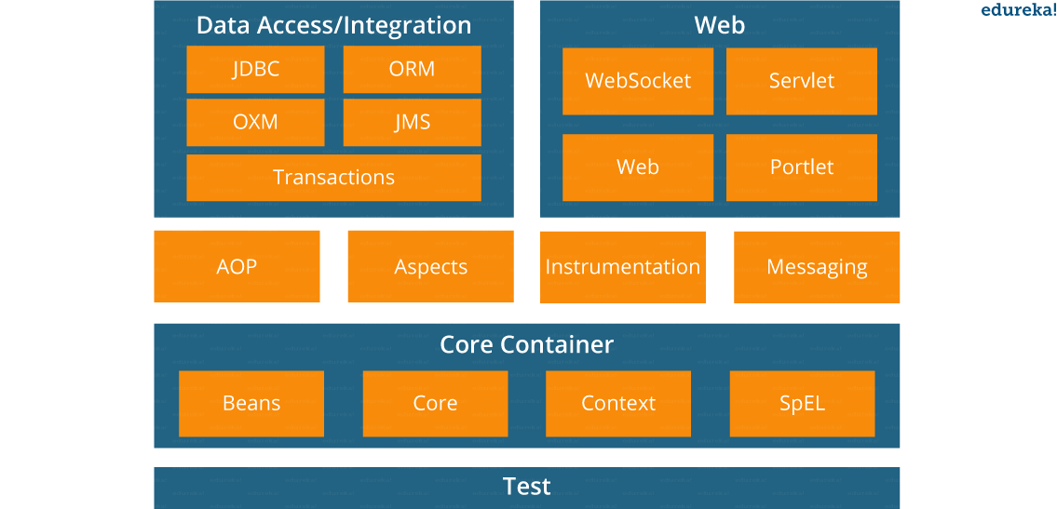

* **Spring Core Container –**This layer is basically the core of Spring Framework.It contains the following modules :

1. Spring Core
2. Spring Bean
3. SpEL (Spring Expression Language)
4. Spring Context

* **Data Access/Integration –**This layer provides support to interact with the database. It contains the following modules :

1. JDBC (Java DataBase Connectivity)
2. ORM (Object Relational Mapping)
3. OXM (Object XML Mappers)
4. JMS (Java Messaging Service)
5. Transaction

* **Web –**This layer provides support to create web application. It contains the following modules :

1. Web
2. Web – MVC
3. Web – Socket
4. Web – Portlet

* **Aspect Oriented Programming (AOP) –** In this layer you can use Advices, Pointcuts etc., to decouple the code.
* **Instrumentation –**This layer provides support to class instrumentation and classloader implementations.
* **Test –**This layer provides support to testing with JUnit and TestNG.

Few Miscellaneous modules are given below:

* **Messaging –**This module provides support for STOMP. It also supports an annotation programming model that is used for routing and processing STOMP messages from WebSocket clients.
* **Aspects –**This module provides support to integration with AspectJ.

## Spring version

|  |
| --- |
|  |
| **Version** | **Date** | **Notes** |
| 0.9 | 2002 |  |
| 1.0 | 2003 |  |
| 2.0 | 2006 |  |
| 3.0 | 2009 |  |
| 4.0 | 2013 |  |
| 5.0 | 2017 |  |

The first version was written by [Rod Johnson](https://en.wikipedia.org/wiki/Rod_Johnson_(programmer)),

|  |  |  |
| --- | --- | --- |
| **Version** | **Logo** | **Feature** |
| **Spring 2.5** | spring 2.5 logo - Spring Interview Questions - Edureka! | This version was released in 2007. It was the first version which supported annotations. |
| **Spring 3.0** | spring 3.0 logo - Spring Interview Questions - Edureka! | This version was released in 2009. Itmade full-fledged use of improvements in Java5 and also provided support to JEE6. |
| **Spring 4.0** | Spring 4.0 logo - Spring Interview Questions - Edureka! | This version was released in 2013. This was the first version to provide full support to Java 8. |

### Spring 5: - <https://springframework.guru/what-is-new-with-spring-framework-5/>

### JDK baseline update

### Core framework revision

### Core container updates

### Functional programming with Kotlin

### Reactive Programming Model

### Testing improvements

### Library support

### Discontinued support

Spring 4 - <https://docs.spring.io/spring/docs/4.2.x/spring-framework-reference/html/new-in-4.0.html>

** The latest version of spring is 5.3.4 as of March 2021.

## Design patterns used in Spring?

### 1. **Dependency injection or inversion of control (IOC):**

### The Spring framework has an IOC container which is responsible for the creation of the objects, wiring the objects together, configuring these objects and handling the entire life cycle of these objects from their creation until they are completely destroyed. The container has the Dependency Injection (DI) which is used to manage the components present in an application. Such objects are known as Spring Beans. The dependency injection or IOC container is the main principle which is used in the spring framework for the decoupling process.

### 2. **Factory Design Pattern:**

### The Spring framework uses the factory design pattern for the creation of the objects of beans by using the following two approaches.

### **Spring BeanFactory Container:** It is the simplest container present in the spring framework which provides the basic support for DI (Dependency Injection). We use the following interface to work with this container.[org.springframework.beans.factory.BeanFactory].

### **Spring ApplicationContext Container:** It is another container present in spring container which adds extra enterprise-specific functionality. These functionalities include the capability to resolve textual messages from a properties file and publishing application events to the attentive event listeners. We use the following interface to work with this container. [org.springframework.context.ApplicationContext]. Below are the most commonly used ApplicationContext implementations. FileSystemXmlApplicationContext (need to provide the full path of the XML bean configuration file to the constructor). ClassPathXmlApplicationContext (need to set CLASSPATH of the bean configuration XML file in order to load the metadata of the beans from an XML file). WebXmlApplicationContext (the container loads the XML file within a web application which has metadata of all beans).

### **Example: –**

### 

|  |  |
| --- | --- |
| 1234567891011121314 | package com.eduonix.springframework.applicationcontext;import org.springframework.context.ApplicationContext;import org.springframework.context.support.FileSystemXmlApplicationContext;public class App {public static void main(String[] args) {ApplicationContext context = new FileSystemXmlApplicationContext("C:/work/IOC Containers/springframework.applicationcontext/src/main/resources/bean-factory-config.xml");HelloApplicationContext obj = (HelloApplicationContext) context.getBean("helloApplicationContext");obj.getMsg();}} |

### **3. Proxy Design Pattern:** In the proxy design pattern, a class is used to represent the functionality of another class. It is an example of a structural pattern. Here, an object is created that has an original object to interface its functionality to the outer world. Proxy design pattern is widely used in AOP, and remoting.

### **4. Singleton Design Pattern:** Singleton design pattern ensures that there will exist only the single instance of the object in the memory that could provide services. In the spring framework, the Singleton is the default scope and the IOC container creates exactly one instance of the object per spring IOC container. Spring container will store this single instance in a cache of singleton beans, and all following requests and references for that named bean will get the cached object as return bean. It is recommended to use the singleton scope for stateless beans. We can set up the bean scope as Singleton or prototype (which creates a new bean object for every new request) in the configuration XML file as shown below.

### 

|  |  |
| --- | --- |
| 1234 | <!-- A bean definition with singleton scope --><bean id = "..." class = "..." scope = "singleton/prototype">   <!-- collaborators and configuration for this bean go here --></bean> |

### 5**. Model View Controller (MVC):** It is a design pattern which comes into picture when we use the spring framework for web programming. Spring MVC is known to be a lightweight implementation as controllers are POJOs against traditional servlets which makes the testing of controllers very comprehensive. A controller returns a logical view name and the view selection with the help of a separate ViewResolver. Therefore, Spring MVC controllers can be used along with different view technologies such as JSP, etc.

### **6. Front Controller Design Pattern:** The front controller design pattern is a technique in software engineering to implement centralized request handling mechanism which is capable of handling all the requests through a single handler. Such handler can perform the authentication, authorization, and logging or request tracking (i.e., pass the requests to the corresponding handlers). Spring framework provides support for the **DispatcherServlet** that ensure to dispatch an incoming request to your controllers.

### **7. View Helper:** Spring framework provides a large number of custom JSP tags as well as velocity macros which assist in the separation of code from the presentation (i.e., views).

### **8. Template method:** Spring framework provides a number of templates to kick start work and complete that piece of work as the best programming practice such as opening and closing connection for JDBC or JMS, etc. E.g., JdbcTemplate, JmsTemplate, and JpaTemplate.

## Spring container?

### At the core of the Spring Framework, lies the Spring container. The container creates the object, wires them together, configures them and manages their complete life cycle. The Spring container makes use of Dependency Injection to manage the components that make up an application. The container receives instructions for which objects to instantiate, configure, and assemble by reading the configuration metadata provided. This metadata can be provided either by XML, Java annotations or Java code.

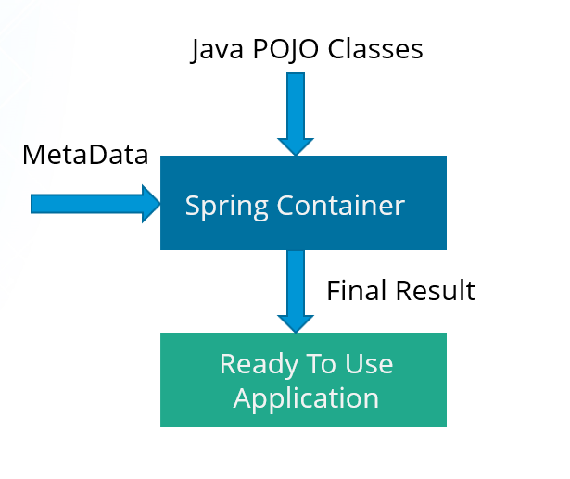

## What is dependency injection?

### In Dependency Injection, **you do not have to create your objects but have to describe how they should be created.**

### You don’t connect your components and services together in the code directly, but describe which services are needed by which components in the configuration file. The IoC container will wire them up together.

## **In how many ways can Dependency Injection be done?**

### In general, dependency injection can be done in three ways, namely :

### Constructor Injection

### Setter Injection

### Interface Injection

### In Spring Framework, only constructor and setter injections are used.

## Which injection is better?

For mandatory properties use Constructor Injection, for non-mandatory use Setter injection. However, we can use @Required in setter as well.

# SPRING CORE

## What is DI?

### It is a process whereby objects define their dependencies. The container then *injects* those dependencies when it creates the bean.

### This process is fundamentally the inverse, hence the name *Inversion of Control* (IoC), of the bean itself controlling the instantiation.

## Constructor DI vs Setter DI?

### Since you can mix constructor-based and setter-based DI, it is a good rule of thumb to use constructors for *mandatory dependencies* and setter methods or configuration methods for *optional dependencies*. Note that use of the @Required annotation on a setter method can be used to make the property a required dependency.

### The Spring team generally advocates constructor injection as it enables one to implement application components as *immutable objects* and to ensure that required dependencies are not null. Furthermore constructor-injected components are always returned to client (calling) code

### in a fully initialized state. As a side note, a large number of constructor arguments is a *bad code smell*, implying that the class likely has too many responsibilities and should be refactored to betteraddress proper separation of concerns.

### Setter injection should primarily only be used for optional dependencies that can be assigned reasonable default values within the class. Otherwise, not-null checks must be performed everywhere the code uses the dependency. One benefit of setter injection is that setter methods make objects of that class amenable to reconfiguration or re-injection later. Management through

### JMX MBeans is therefore a compelling use case for setter injection.

### Use the DI style that makes the most sense for a particular class. Sometimes, when dealing with third-party classes for which you do not have the source, the choice is made for you. For example,

### if a third-party class does not expose any setter methods, then constructor injection may be the only available form of DI.

### Setter injection advantages:

### **Partial dependency**: can be injected using setter injection but it is not possible by constructor. Suppose there are 3 properties in a class, having 3 arg constructor and setters methods. In such case, if you want to pass information for only one property, it is possible by setter method only.

### **Overriding**: Setter injection overrides the constructor injection. If we use both constructor and setter injection, IOC container will use the setter injection.

### **Changes**: We can easily change the value by setter injection. It doesn't create a new bean instance always like constructor. So setter injection is flexible than constructor injection.

<https://spring.io/blog/2007/07/11/setter-injection-versus-constructor-injection-and-the-use-of-required>

## Spring IOC container?

### The interface org.springframework.context.ApplicationContext represents the Spring IoC container and is responsible for instantiating, configuring, and assembling the aforementioned beans.

### The container gets its instructions on what objects to instantiate, configure, and assemble by reading configuration metadata. The configuration metadata is represented in XML, Java annotations, or Java code. It allows you to express the objects that compose your application and the rich interdependencies between such objects.

### The following diagram is a high-level view of how Spring works. Your application classes are combined with configuration metadata so that after the ApplicationContext is created and initialized, you have a fully configured and executable system or application.

### *Figure 3.1. The Spring IoC container*



## IOC in Spring? beanFactory vs ApplicationFactory?

### The org.springframework.beans and org.springframework.context packages are the basis for Spring Framework’s IoC container. The BeanFactory interface provides an advanced configuration mechanism capable of managing any type of object.

### ApplicationContext is a subinterface of BeanFactory. It adds easier integration with Spring’s AOP features; message resource handling (for use in internationalization), event publication; and application-layer specific contexts such as the WebApplicationContext for use in web applications.

### In short, the BeanFactory provides the configuration framework and basic functionality, and the ApplicationContext adds more enterprise-specific functionality. The ApplicationContext is a complete superset of the BeanFactory.

## Types of IOC container?

### **BeanFactory**: BeanFactory is like a factory class that contains a collection of beans. It instantiates the bean whenever asked for by clients.

### **ApplicationContext**: The ApplicationContext interface is built on top of the BeanFactory interface. It provides some extra functionality on top BeanFactory.

#### **BeanFactory vs ApplicationContext**

|  |  |
| --- | --- |
| **BeanFactory** | **ApplicationContext** |
| It is an interface defined in org.springframework.beans.factory.**BeanFactory** | It is an interface defined in org.springframework.context.**ApplicationContext** |
| It uses **Lazy initialization** | It **uses Eager/ Aggressive initialization** |
| It explicitly provides a resource object using the syntax | It creates and manages resource objects on its own |
| It doesn’t supports internationalization | It supports internationalization |
| It doesn’t supports annotation based dependency  .  Do not support event publish. | It supports annotation based dependency .  Event publish is supported. |

### Short version: use an ApplicationContext unless you have a really good reason for not doing so. For those of you that are looking for slightly more depth as to the 'but why' of the above recommendation, keep reading.

### As the ApplicationContext includes all functionality of the BeanFactory, it is generally recommended that it be used in preference to the BeanFactory, except for a few limited situations such as in an Applet, where memory consumption might be critical and a few extra kilobytes might make a difference. However, for most 'typical' enterprise applications and systems, the ApplicationContext is what you will want to use. Versions of Spring 2.0 and above make heavy use of the [BeanPostProcessor extension point](https://docs.spring.io/spring-framework/docs/3.0.0.M3/reference/html/ch04s07.html#beans-factory-extension-bpp) (to effect proxying and suchlike), and if you are using just a plain BeanFactory then a fair amount of support such as transactions and AOP will not take effect (at least not without some extra steps on your part), which could be confusing because nothing will actually be wrong with the configuration.

### Find below a feature matrix that lists what features are provided by the BeanFactory and ApplicationContext interfaces (and attendant implementations). (The following sections describe functionality that ApplicationContext adds to the basic BeanFactory capabilities in a lot more depth than the said feature matrix.)

### Table 4.5. Feature Matrix

| Feature | BeanFactory | ApplicationContext |
| --- | --- | --- |
| Bean instantiation/wiring | Yes | Yes |
| Automatic BeanPostProcessor registration | No | Yes |
| Automatic BeanFactoryPostProcessor registration | No | Yes |
| Convenient MessageSource access (for i18n) | No | Yes |
| ApplicationEvent publication | No | Yes |

## Additional capability of Application context?

### *Access to messages in i18n-style*, through the MessageSource interface.

### • *Access to resources*, such as URLs and files, through the ResourceLoader interface.

### • *Event publication* to namely beans implementing the ApplicationListener interface, through the

### use of the ApplicationEventPublisher interface.

### • *Loading of multiple (hierarchical) contexts*, allowing each to be focused on one particular layer, such

### as the web layer of an application, through the HierarchicalBeanFactory interface.

## How to instantiate a Spring IOC container?

ApplicationContext context =

**new** ClassPathXmlApplicationContext(**new** String[] {***"services.xml"***, ***"daos.xml"***});

The ApplicationContext is the interface for an advanced factory capable of maintaining a registry of different beans and their dependencies. Using the method T getBean(String name, Class<T> requiredType) you can retrieve instances of your beans. The ApplicationContext enables you to read bean definitions and access them as follows:

*// create and configure beans*

ApplicationContext context =

**new** ClassPathXmlApplicationContext(**new** String[] {***"services.xml"***, ***"daos.xml"***});

*// retrieve configured instance*

PetStoreService service = context.getBean(***"petStore"***, PetStoreService.**class**);

*// use configured instance*

List<String> userList = service.getUsernameList();

## What is spring bean?

### They are the objects that form the backbone of the user’s application.

### Beans are managed by the Spring IoC container.

### They are instantiated, configured, wired and managed by a Spring IoC container

### Beans are created with the configuration metadata that the users supply to the container.

### Bean generation - Spring Interview Questions - Edureka!

## What is bean wiring?

### The act of creating these associations between application objects is the essence of dependency injection (DI) and is commonly referred to as wiring.

Different ways of wiring-

### Explicit configuration in XML

### ○ Explicit configuration in Java

### ○ Implicit bean discovery and automatic wiring

### **XML-Based configuration:**In Spring Framework, the dependencies and the services needed by beans are specified in configuration files which are in XML format. These configuration files usually contain a lot of bean definitions and application specific configuration options. They generally start with a bean tag. For example:

|  |  |
| --- | --- |
| 123 | <bean id="studentbean" class="org.edureka.firstSpring.StudentBean"> <property name="name" value="Edureka"></property></bean> |

### **Annotation-Based configuration**: Instead of using XML to describe a bean wiring, you can configure the bean into the component class itself by using annotations on the relevant class, method, or field declaration. By default, annotation wiring is not turned on in the Spring container. So, you need to enable it in your Spring configuration file before using it. For example:

|  |  |
| --- | --- |
| 1234 | <beans><context:annotation-config/><!-- bean definitions go here --></beans> |

### **Java-based configuration:**The key features in Spring Framework’s new Java-configuration support are @Configuration annotated classes and @Bean annotated methods.

### 1. @Bean annotation plays the same role as the <bean/> element.

### 2.@Configuration classes allows to define inter-bean dependencies by simply calling other @Bean methods in the same class.

## Explain Spring dependency injection with XML config?

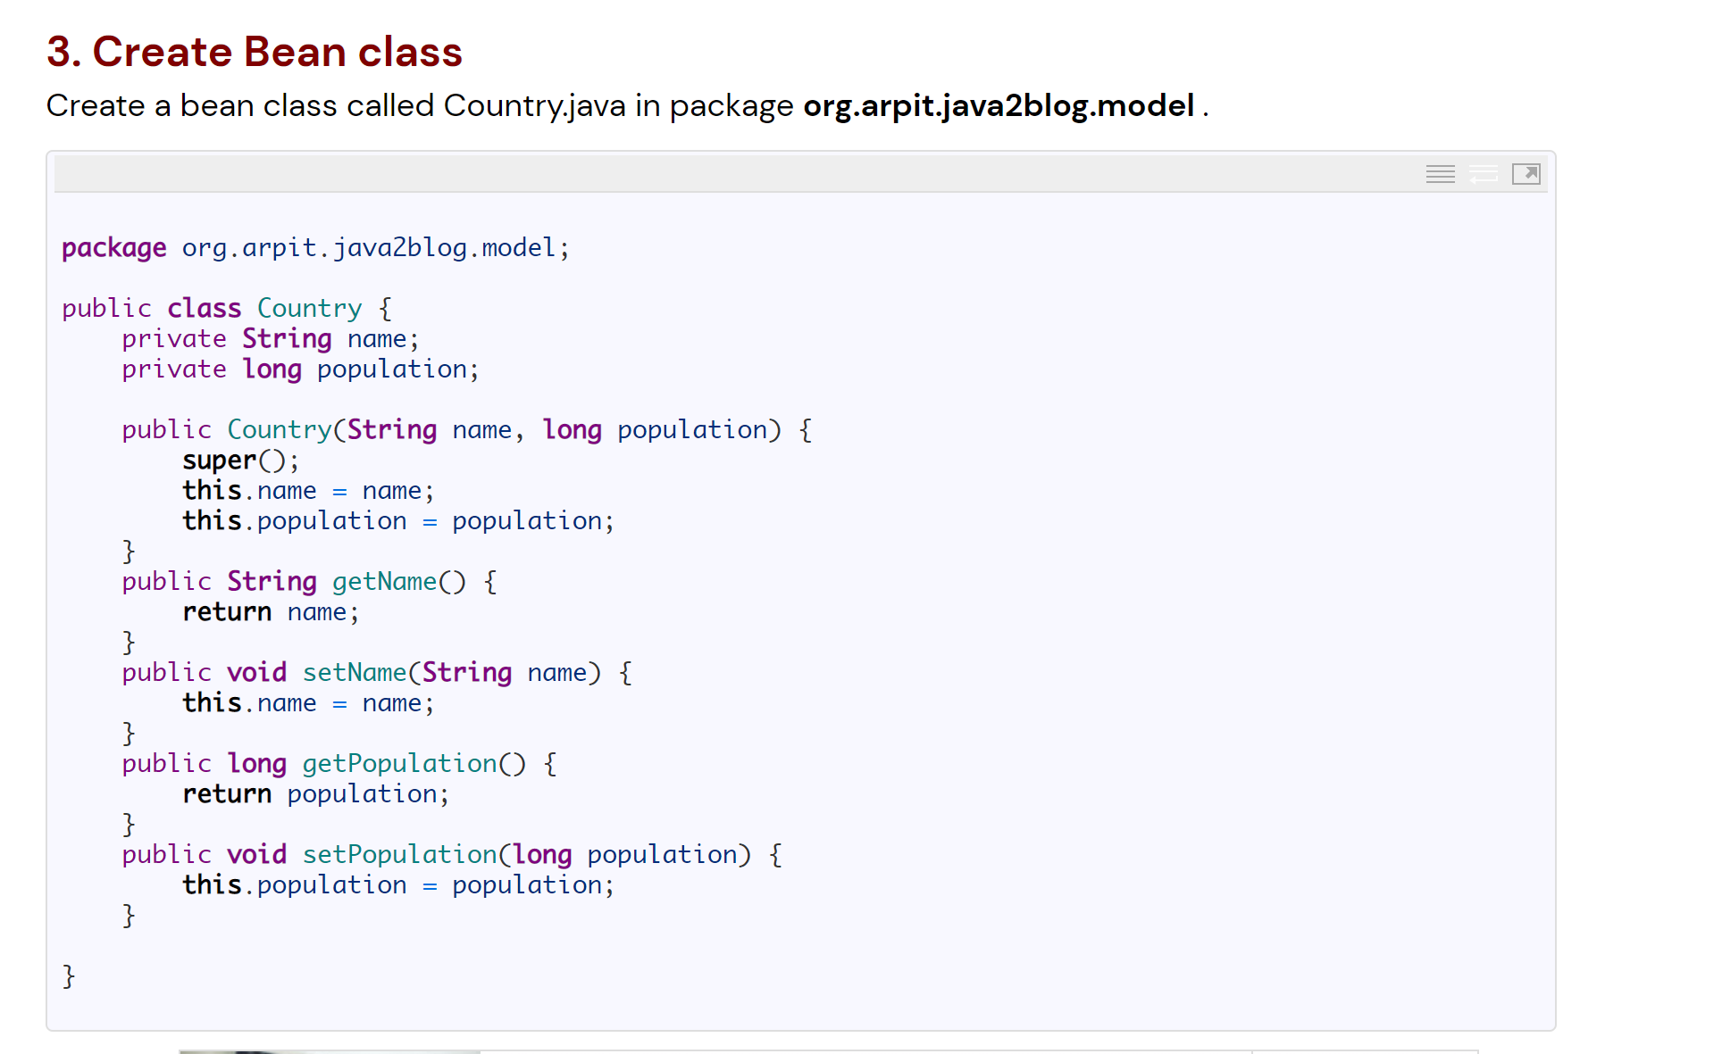

Create beans.xml or applicationContext.xml or any xml file-

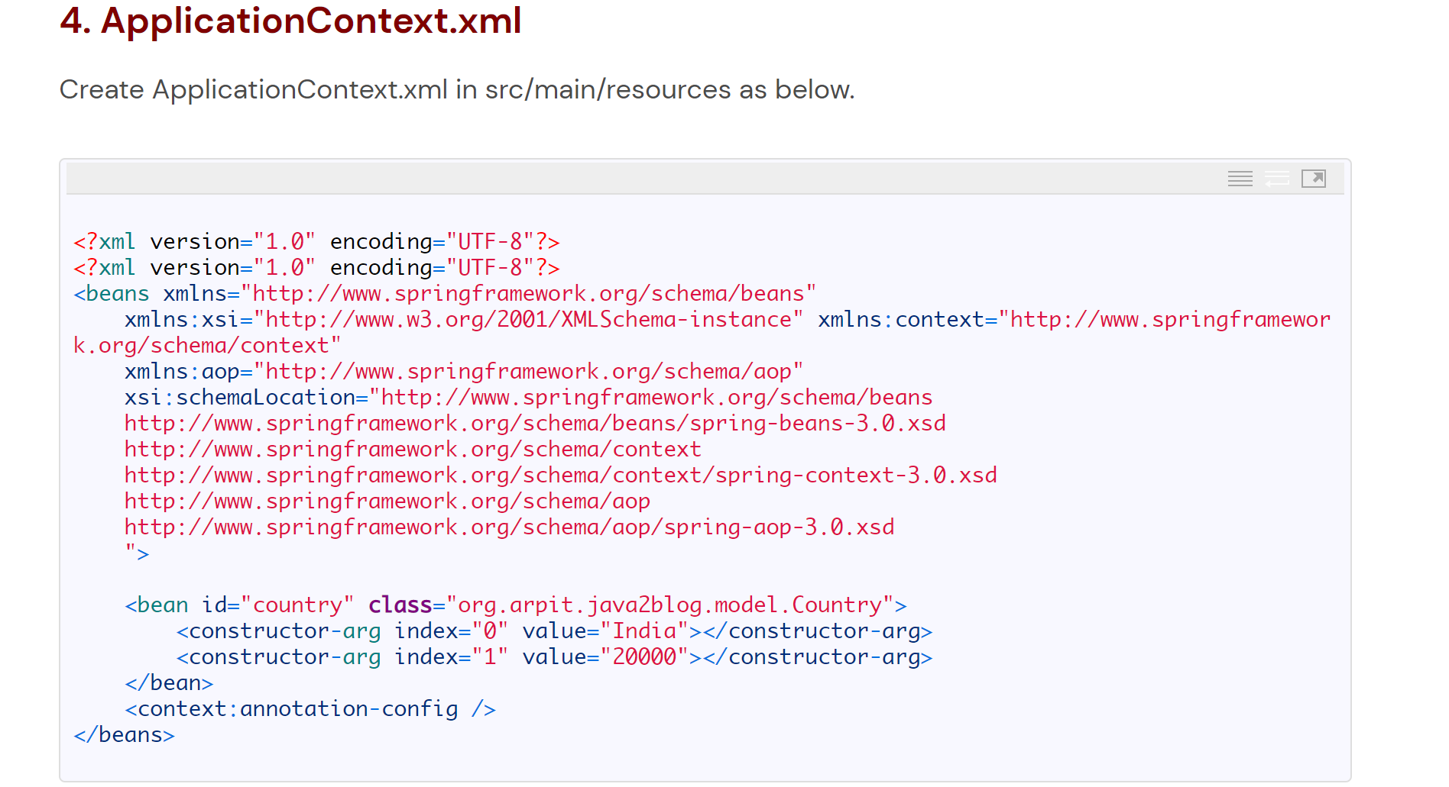

This is Constructor injection example..

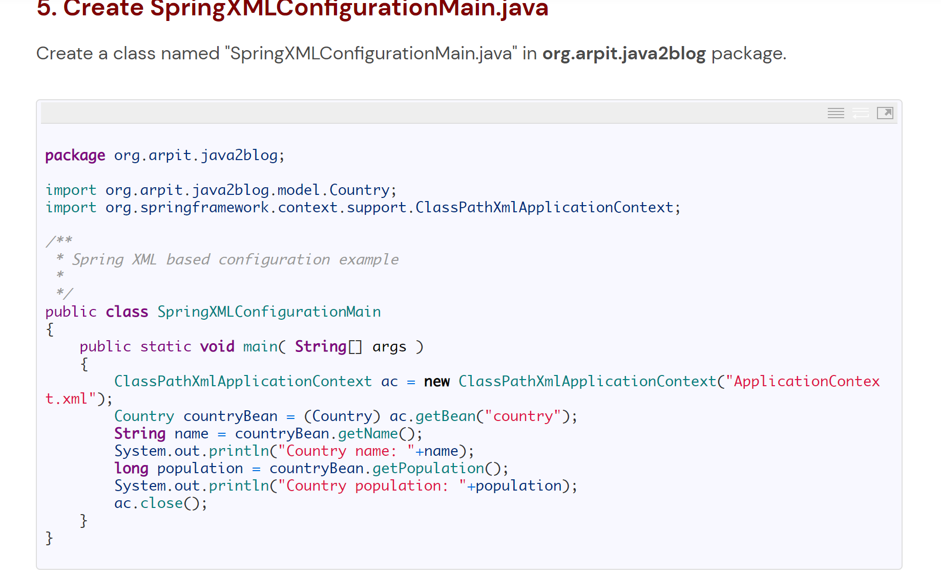

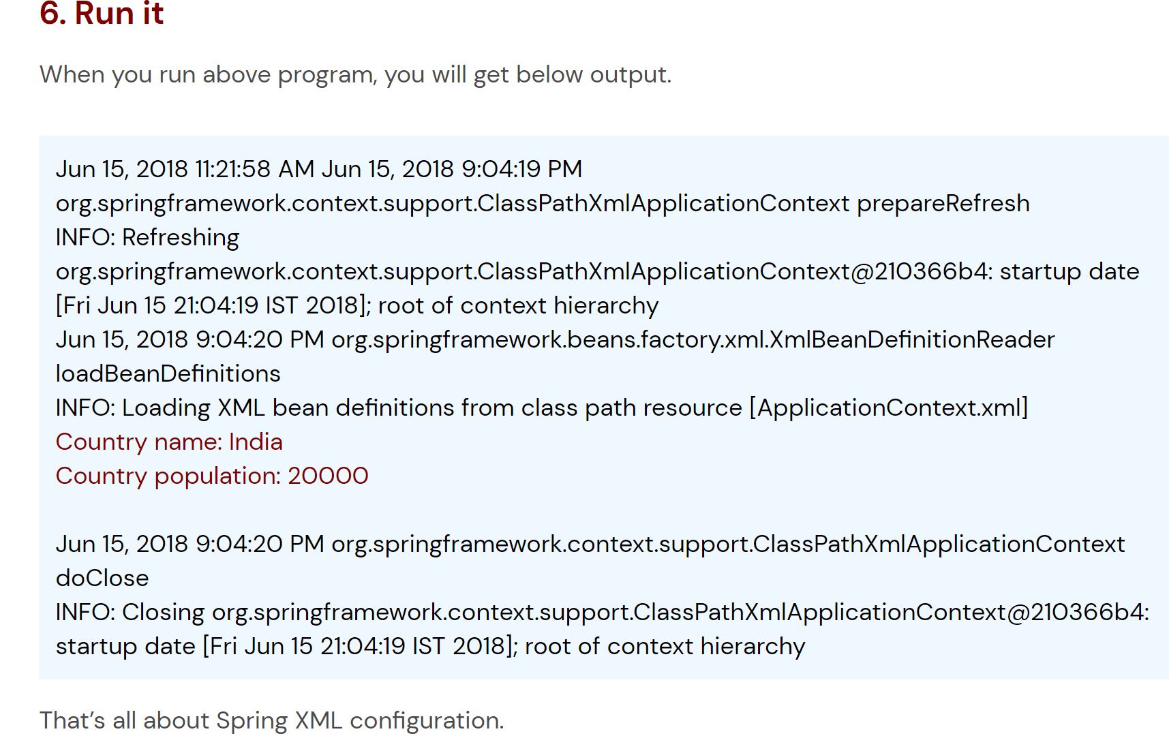

<https://java2blog.com/spring-xml-configuration/>

more detailed example can be found here:

<https://www.codejava.net/frameworks/spring/spring-dependency-injection-example-with-xml-configuration>

## Explain spring DI using annotation.

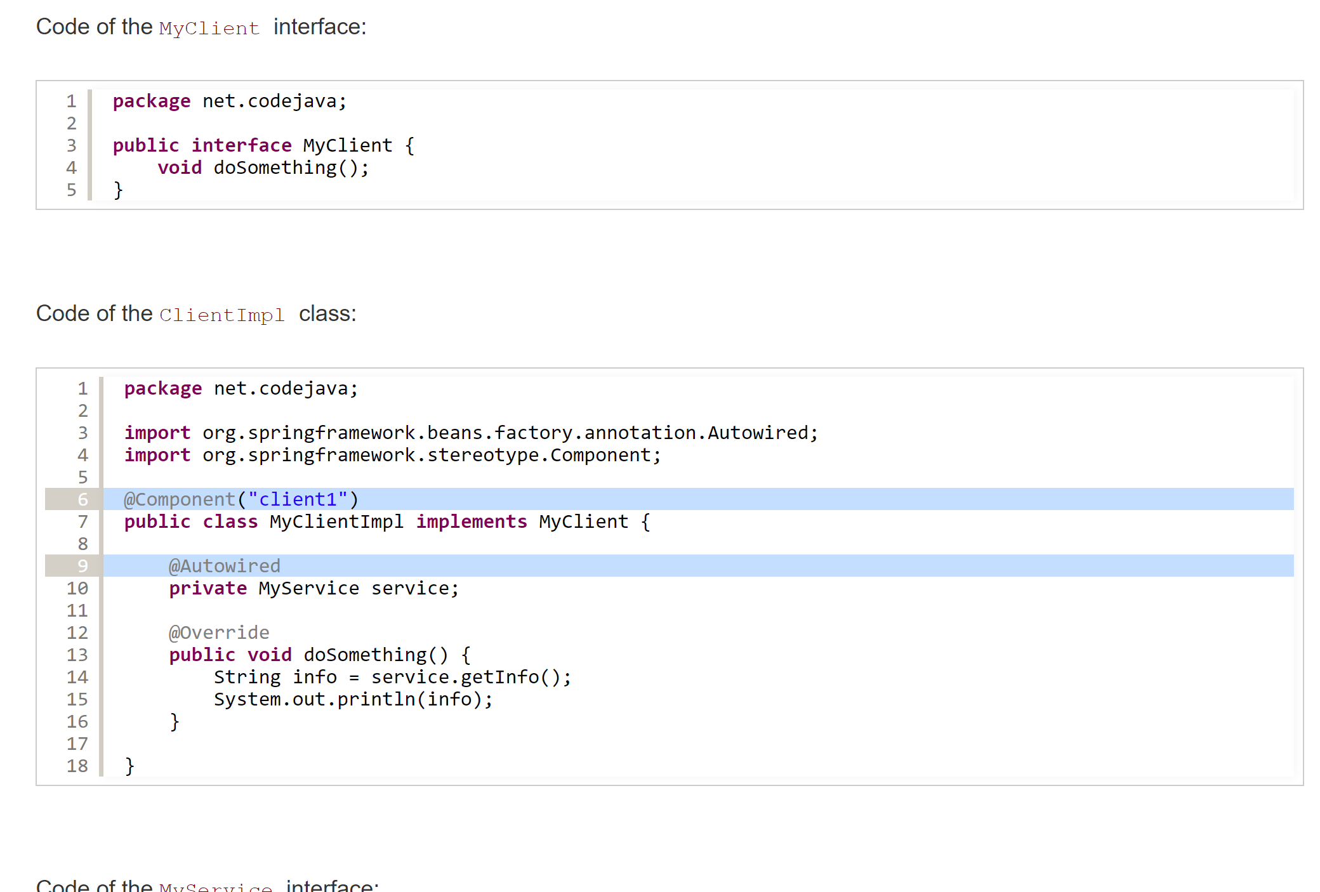

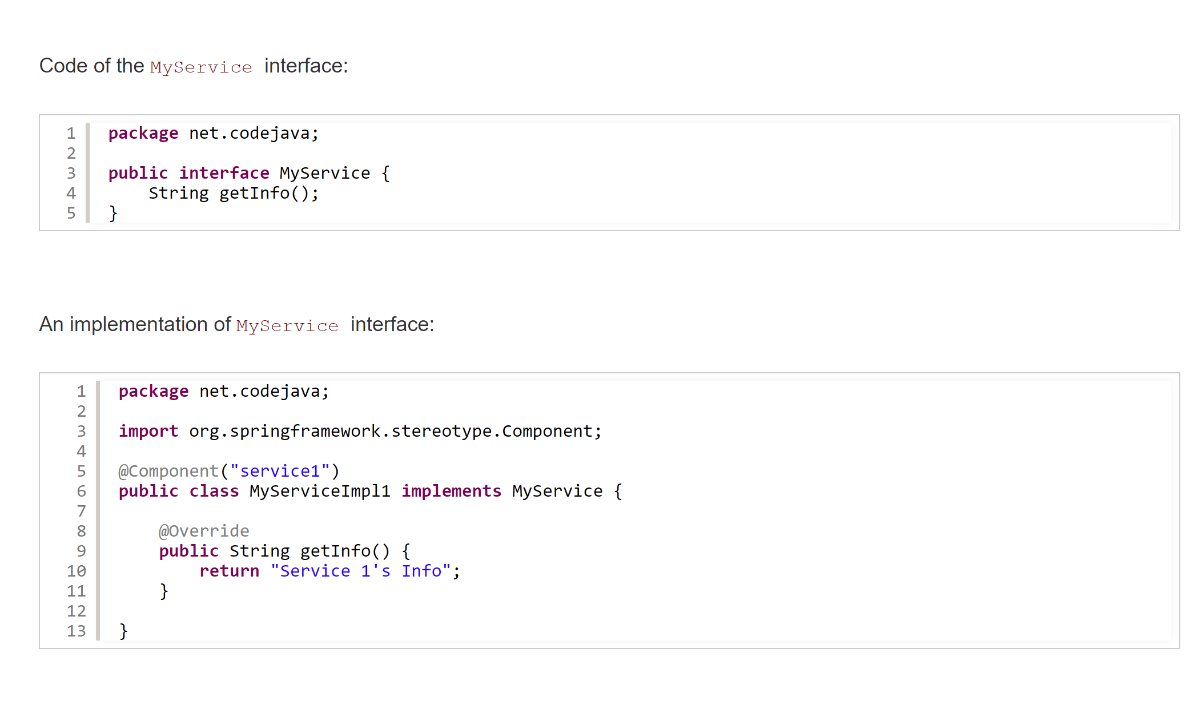

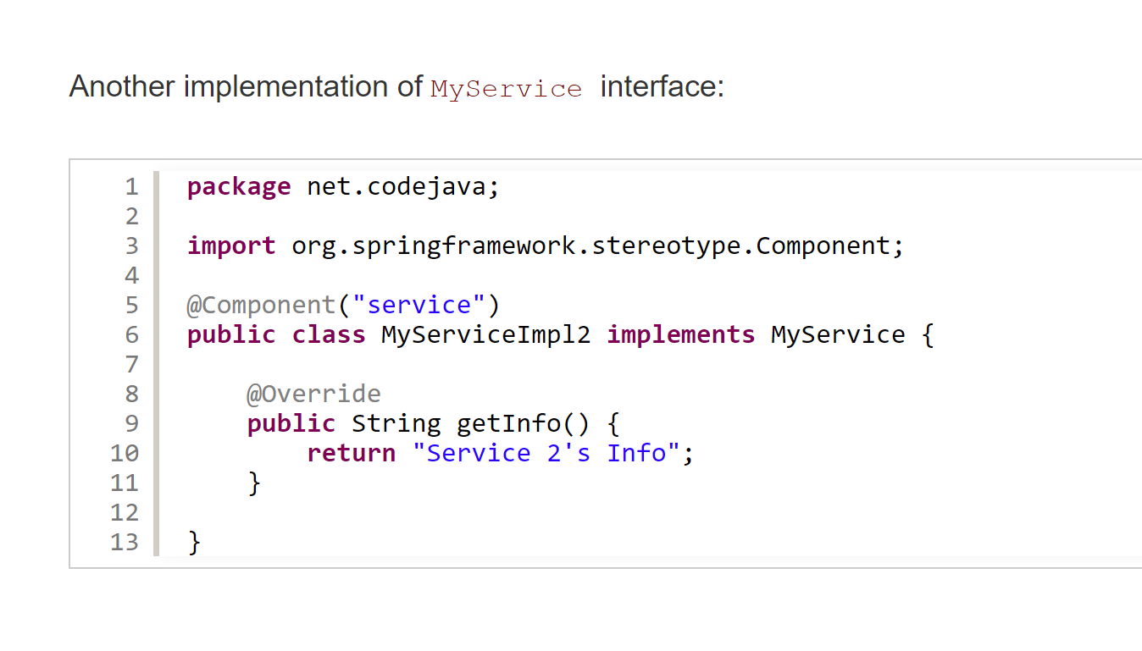

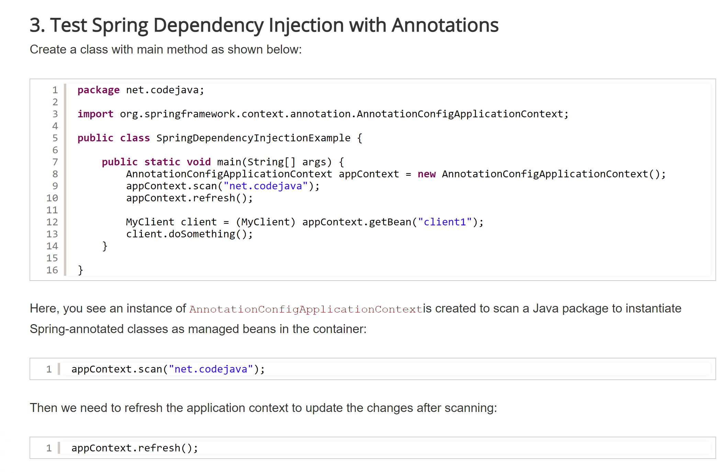

Output: service 2’s info

### - There cannot have two beans in the IoC container with the same name, so the name you specify in the @Component must be unique.

### - You can also mark a class with @Service and @Repository annotations. These annotations have same technical purpose as the @Component annotation. They have different names to mark classes in different layers of the application.

### - The @Autowired annotation can be also applied on setter method and constructor

**- If you have defined both ways, XML and annotation, XML configuration will take precedence.**

<https://java2blog.com/spring-java-based-configuration-example/>

<https://www.codejava.net/frameworks/spring/spring-dependency-injection-example-with-annotations>

## Explain configuration using java Config?

### Spring allows you to make dependency injection using XML and annotations - but they have some drawbacks:

### - [**Dependency injection via XML**](https://www.codejava.net/frameworks/spring/spring-dependency-injection-example-with-xml-configuration): though this makes configured classes independent of Spring API, the nature of XML makes it hard to navigate through the dependency relationship among classes when the application’s code grows and becomes more complex.

### - [**Dependency injection using annotations**](https://www.codejava.net/frameworks/spring/spring-dependency-injection-example-with-annotations)**:** this makes the configured classes tightly coupled with Spring API - the @Component, @Service, @Autowired… annotations.

### Therefore, Spring provides Java config approach for dependency injection, which can eliminate the drawbacks of XML and annotations: configured classes are not polluted by Spring annotations and they are easily navigable.

### Let’s see how dependency injection can be done with Java configuration in Spring.

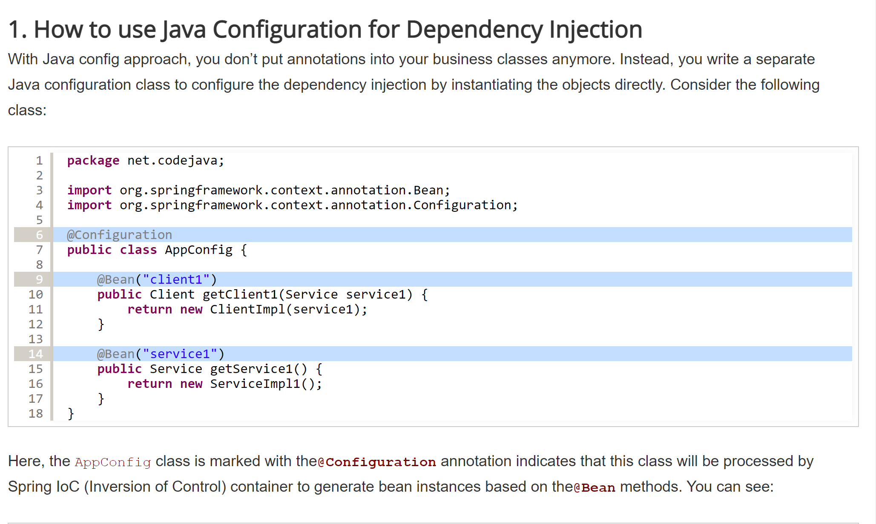

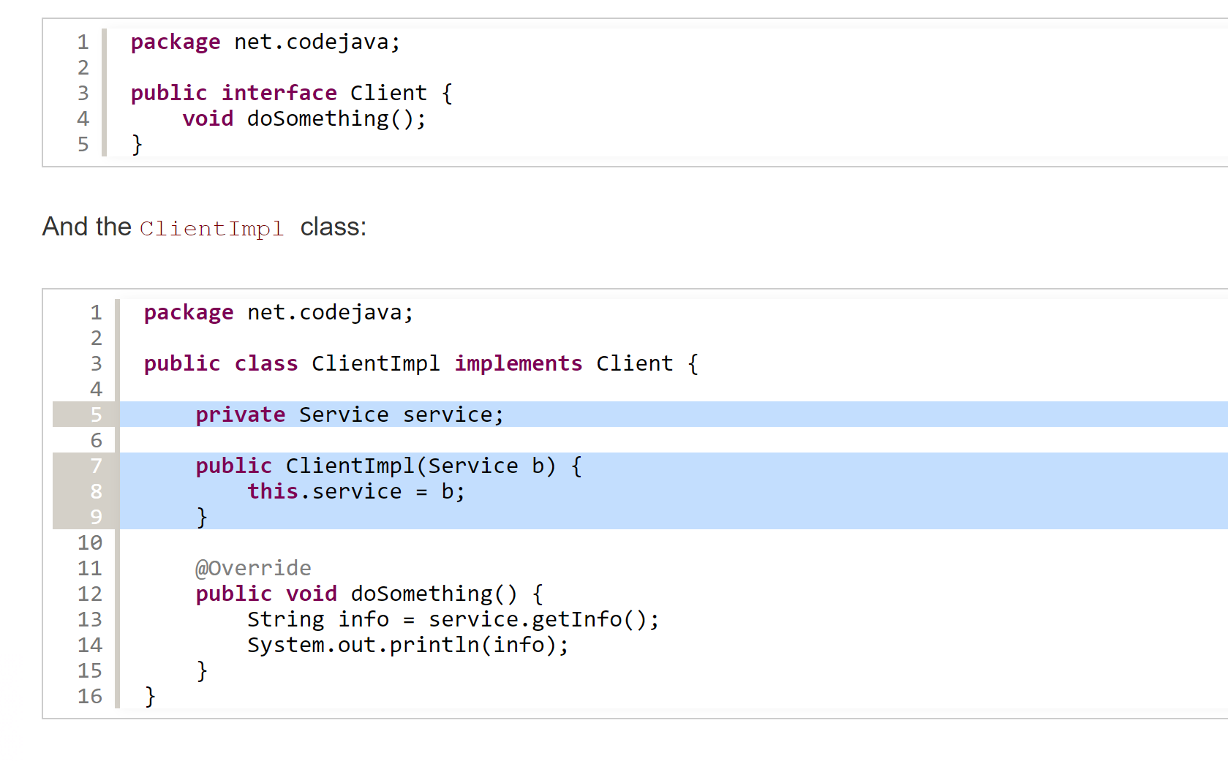

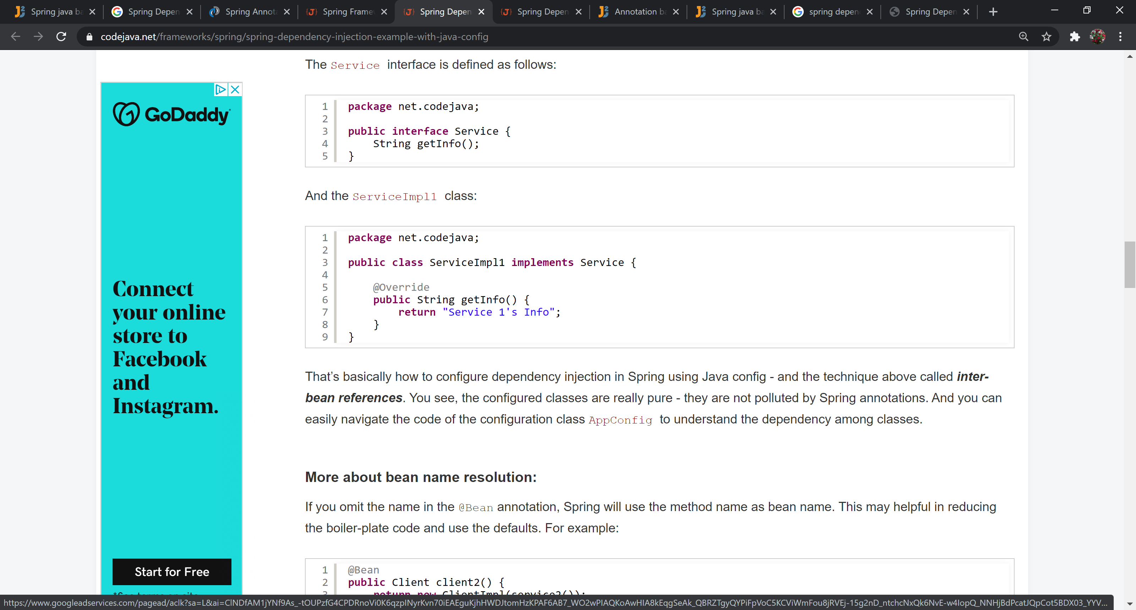

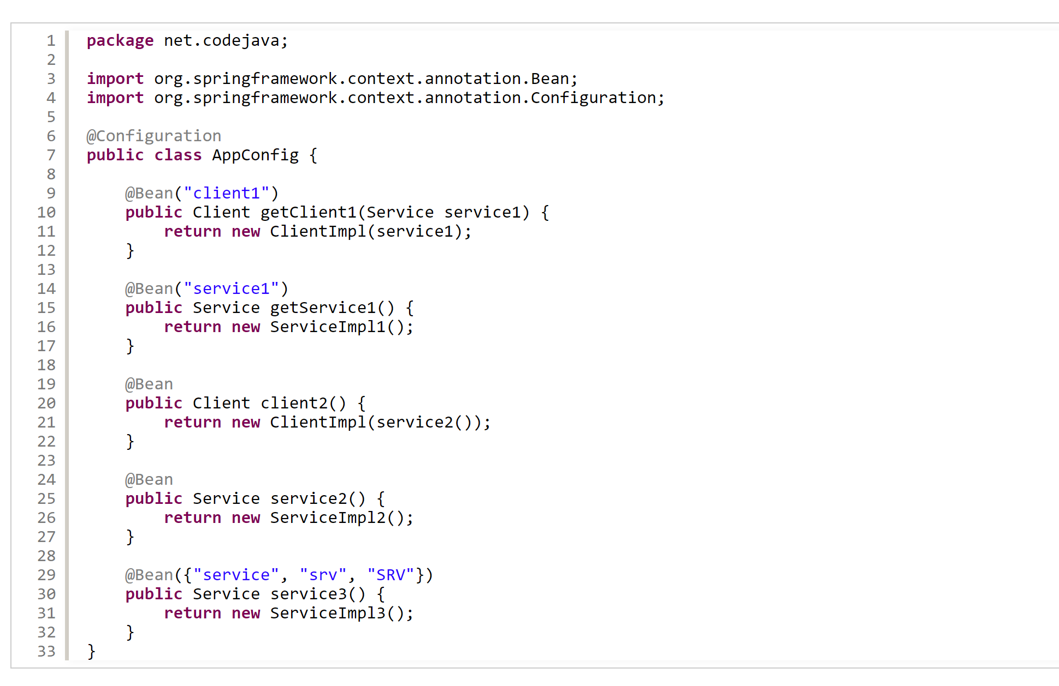

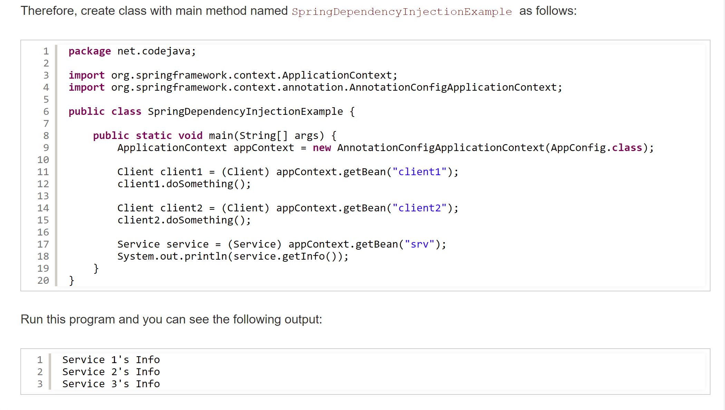

## What are the bean scopes?

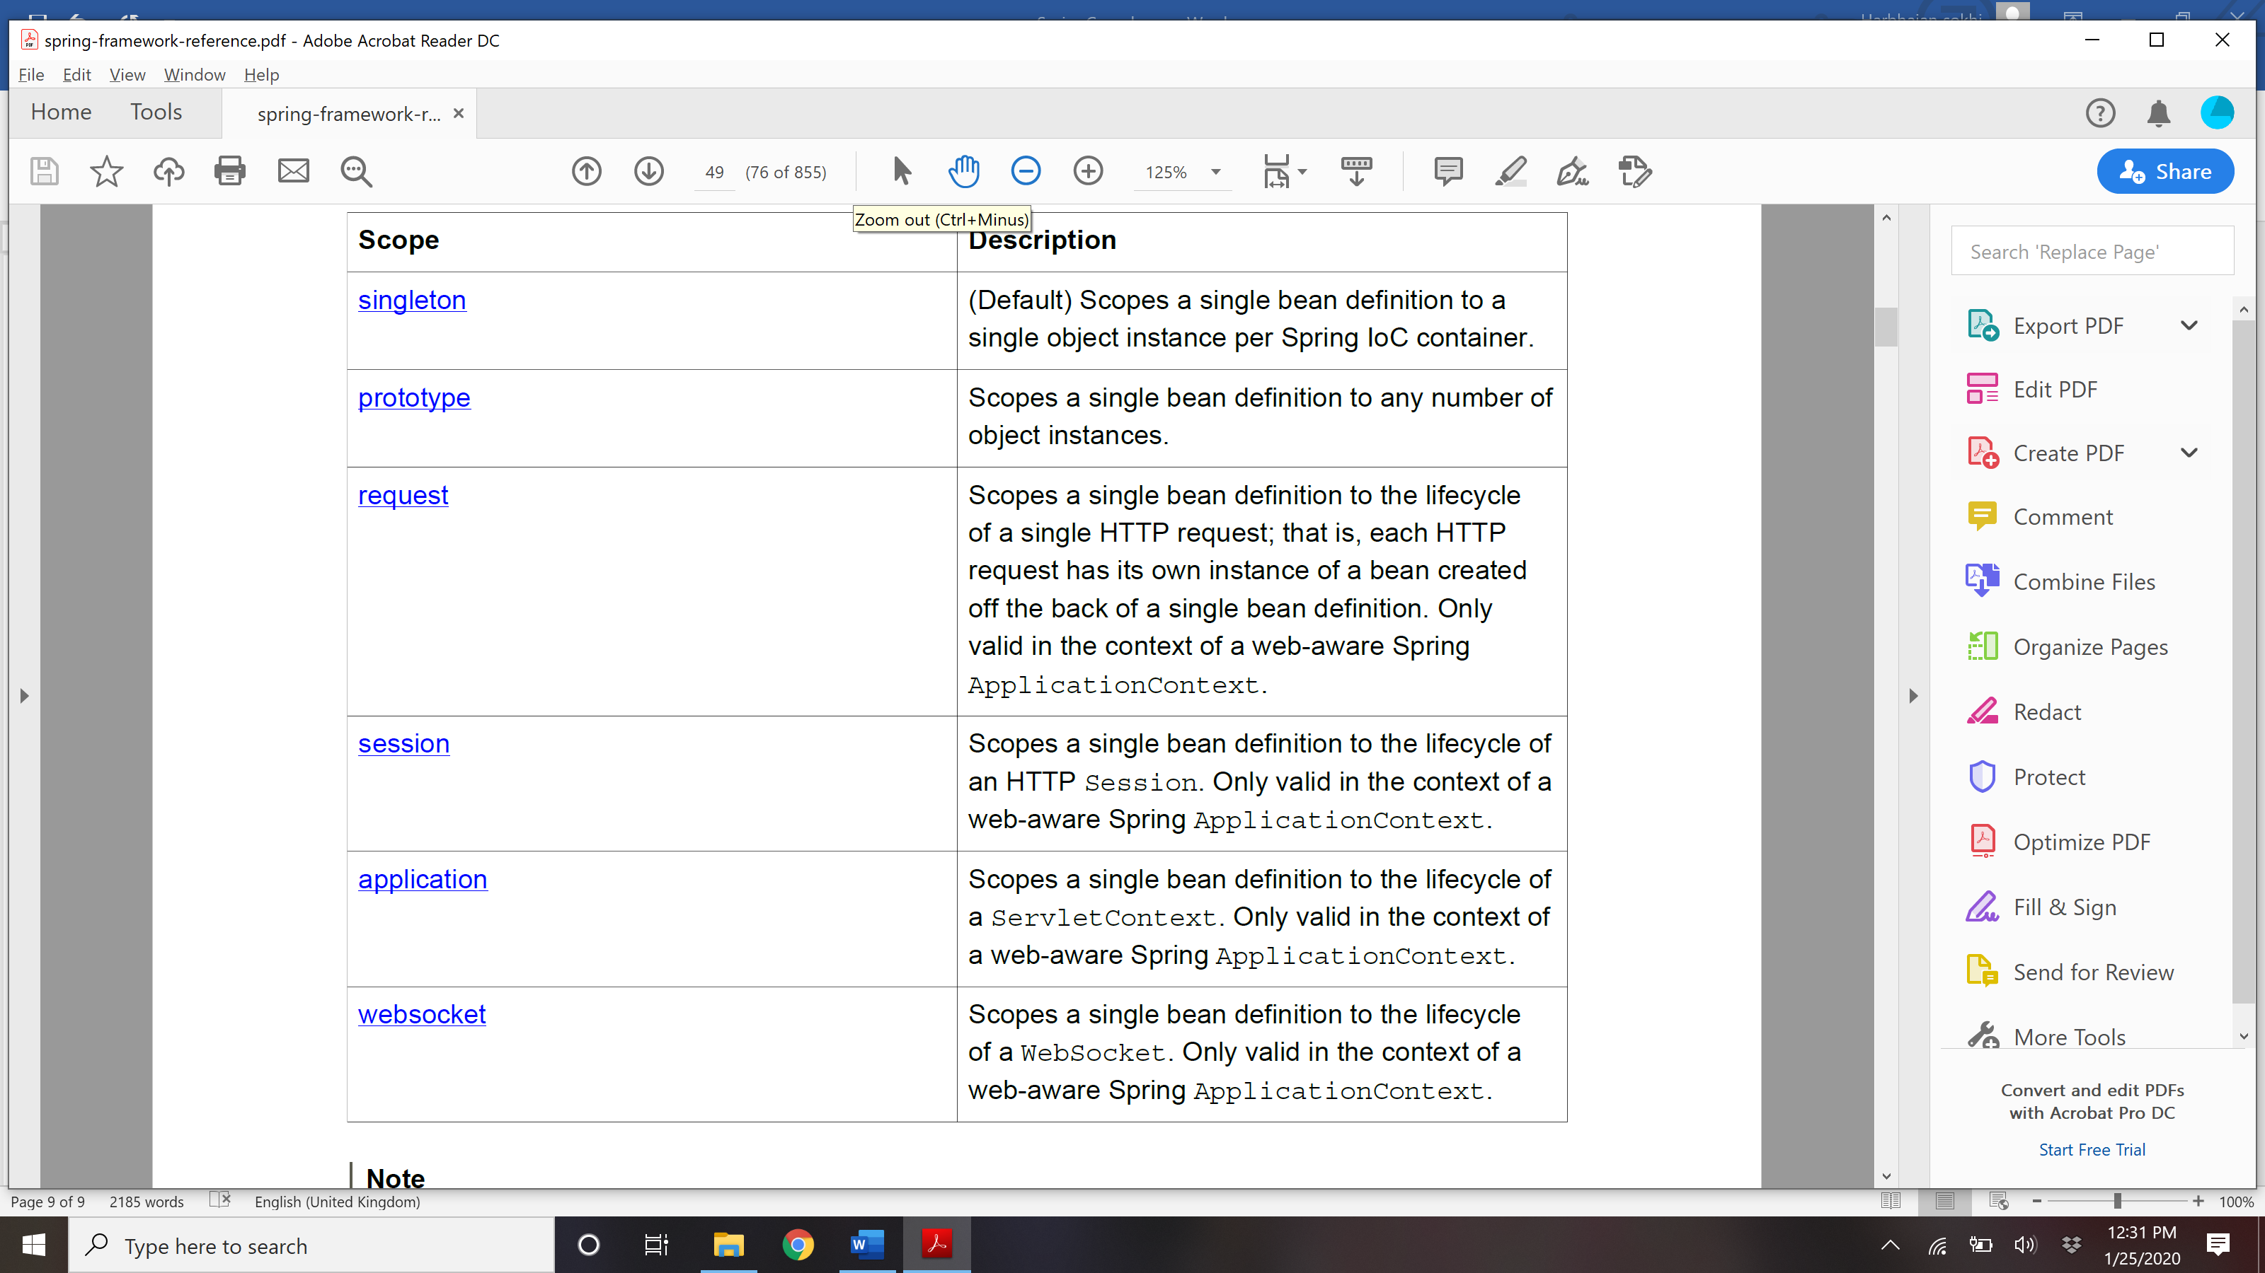

### **Singleton Scope:** Spring’s concept of a singleton bean differs from the Singleton pattern as defined in the Gang of Four (GoF) patterns book. The GoF Singleton hard-codes the scope of an object such that one *and only* *one* instance of a particular class is created *per ClassLoader*. **The scope of the Spring singleton is best described as *per container and per bean***. This means that if you define one bean for a particular class in a single Spring container, then the Spring container creates one *and only one* instance of the class defined by that bean definition.

**Prototype**:

### The following example defines a bean as a prototype in XML:

### **<bean id**=**"accountService" class**=**"com.foo.DefaultAccountService" scope**=**"prototype"/>**

### In contrast to the other scopes, **Spring does not manage the complete lifecycle of a prototype bean**: the container instantiates, configures, and otherwise assembles a prototype object, and hands it to the client,

### with no further record of that prototype instance. Thus, although *initialization* lifecycle callback methods are called on all objects regardless of scope, in the case of prototypes, **configured *destruction* lifecycle callbacks are *not* called**. The client code must clean up prototype-scoped objects and release expensive resources that the prototype bean(s) are holding. To get the Spring container to release resources held by prototype-scoped beans, try using a custom bean post-processor, which holds a reference to beans

### that need to be cleaned up.

### In some respects, the Spring container’s role in regard to a prototype-scoped bean is a replacement for the Java new operator. All lifecycle management past that point must be handled by the client.

Other scopes:

### The request, session, application, and websocket scopes are *only* available if you use a web-aware Spring ApplicationContext implementation (such as XmlWebApplicationContext). If you use these scopes with regular Spring IoC containers such as the ClassPathXmlApplicationContext, an IllegalStateException will be thrown complaining about an unknown bean scope.

### ** As of Spring 3.0, a *thread scope* is available, but is not registered by default. For more information, see the documentation for SimpleThreadScope.

## How Spring manages singleton bean with prototype bean dependencies?

### When you use singleton-scoped beans with dependencies on prototype beans, be aware that *dependencies are resolved at instantiation time*. Thus if you inject a prototype-scoped bean into a singleton-scoped bean, a new prototype bean is instantiated and then injected into the singleton bean. The prototype instance is the sole instance that is ever supplied to the singleton scoped bean.

### However, suppose you want the singleton-scoped bean to acquire a new instance of the prototype scoped bean repeatedly at runtime. You cannot dependency-inject a prototype-scoped bean into your singleton bean, because that injection occurs only *once*, when the Spring container is instantiating the

### singleton bean and resolving and injecting its dependencies. If you need a new instance of a prototype bean at runtime more than once, read the section called “Method injection”.

## How to create a custom scope?

You can create your own scope by implementing Scope interface in spring and implement all 4 methods defined in this interfafce. After creating your own implementation, register your scope in ConfigurableBeanFactory. See Spring-framework-reference book for more details.

## Bean Lifecycle?

When container starts – a Spring bean needs to be instantiated, based on Java or XML bean definition. It may also be required to perform some post-initialization steps to get it into a usable state. Same bean life cycle is for [*spring boot*](https://howtodoinjava.com/spring-boot-tutorials/) applications as well. After that, when the bean is no longer required, it will be removed from the IoC container. Spring bean factory is responsible for managing the life cycle of beans created through spring container.

**Life cycle callbacks**

Spring bean factory controls the creation and destruction of beans. To execute some custom code, it provides the call back methods which can be categorized broadly in two groups:

* **Post-initialization** call back methods
* **Pre-destruction** call back methods

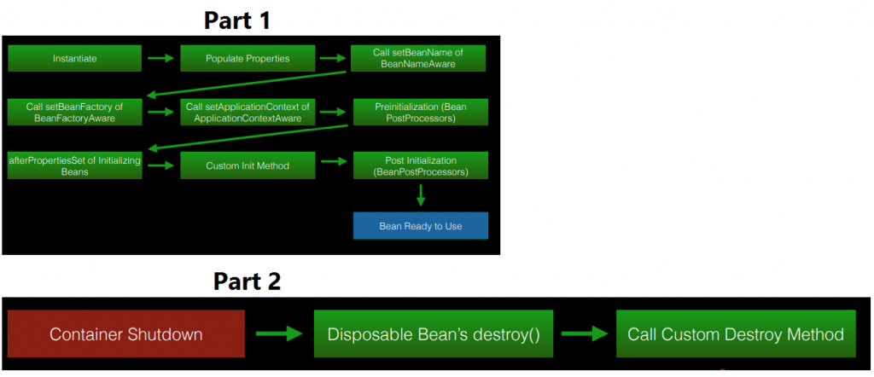

Spring Bean Life Cycle

## Explain Life cycle callback methods of Bean.

### Spring framework provides following **4 ways for controlling life cycle events** of a bean:

### InitializingBean and DisposableBean callback interfaces

### *Aware interfaces for specific behavior

### Custom init() and destroy() methods in bean configuration file

### @PostConstruct and @PreDestroy annotations

### **InitializingBean and DisposableBean**

### The [org.springframework.beans.factory.InitializingBean](http://static.springsource.org/spring/docs/3.0.x/javadoc-api/org/springframework/beans/factory/InitializingBean.html) interface allows a bean to perform initialization work after all necessary properties on the bean have been set by the container. The InitializingBean interface specifies a single method: **void afterPropertiesSet() throws Exception;**

### Similarly, implementing the [org.springframework.beans.factory.DisposableBean](http://static.springsource.org/spring/docs/1.2.9/api/org/springframework/beans/factory/DisposableBean.html) interface allows a bean to get a callback when the container containing it is destroyed. The DisposableBean interface specifies a single method: **void destroy() throws Exception**

### This is not a preferrable way to initialize the bean because it tightly couple your bean class with spring container. A better approach is to use “init-method” attribute in bean definition in applicationContext.xml file.

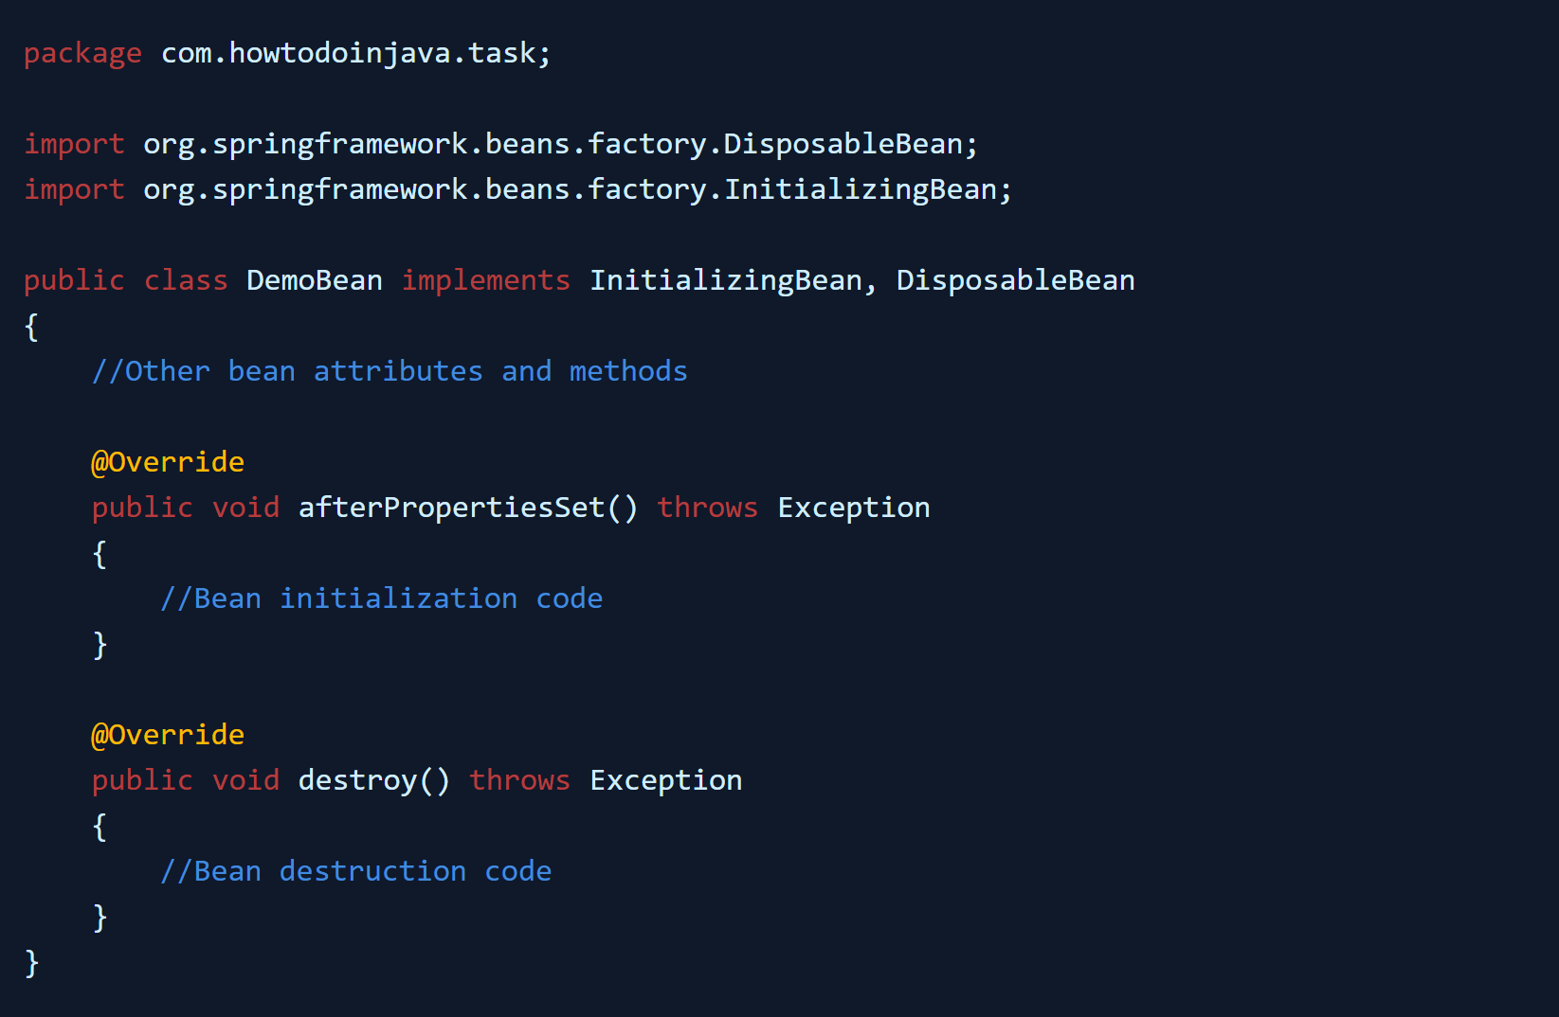

### \***Aware interfaces for specific behavior**

### Spring offers a range of *Aware interfaces that allow beans to indicate to the container that they require a certain infrastructure dependency. Each interface will require you to implement a method to inject the dependency in bean.

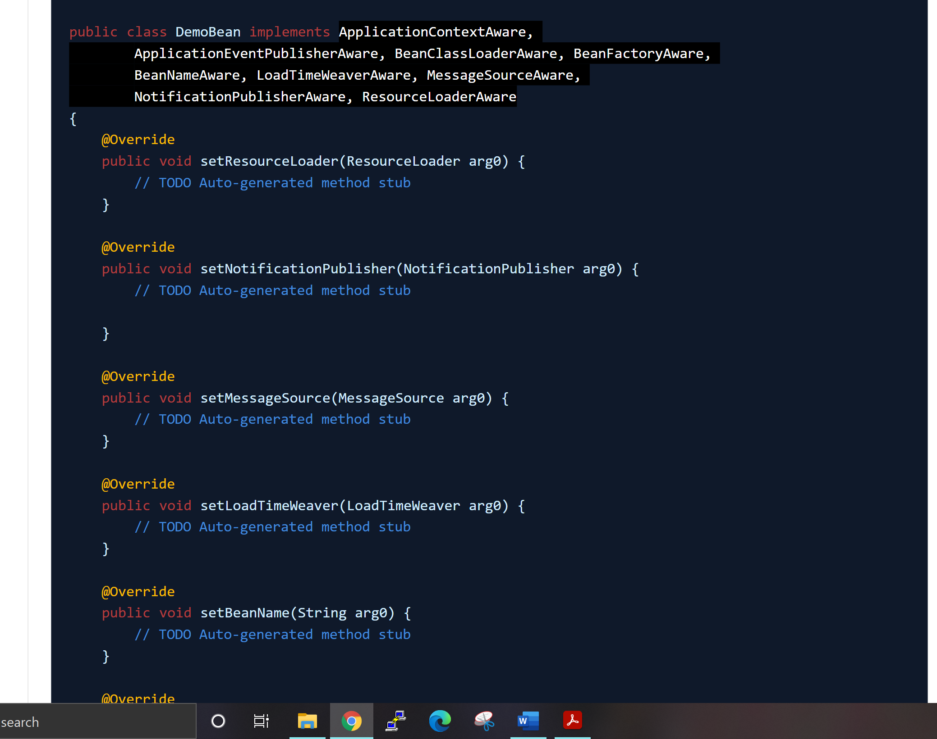

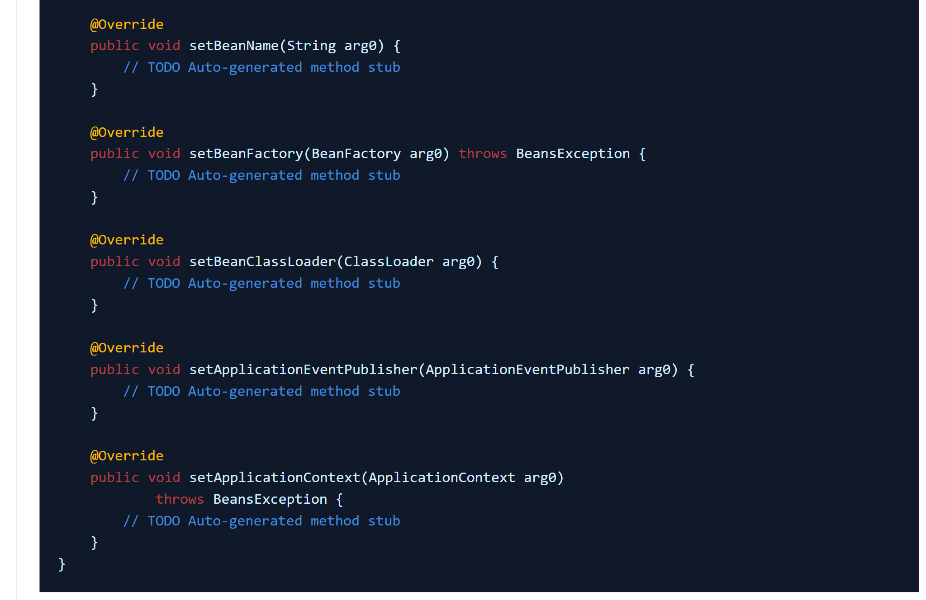

### **Custom init() and destroy() methods**

### The default init and destroy methods in bean configuration file can be defined in two ways: Local and Global

### **Bean local definition** applicable to a single bean

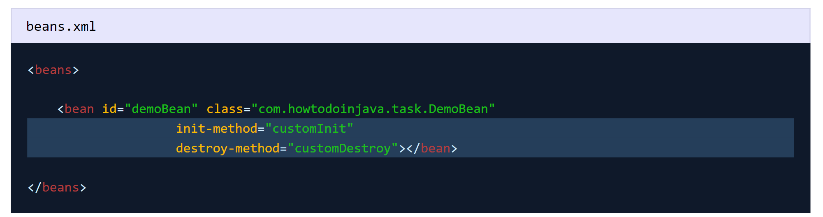

### **Global definition** applicable to all beans defined in beans context

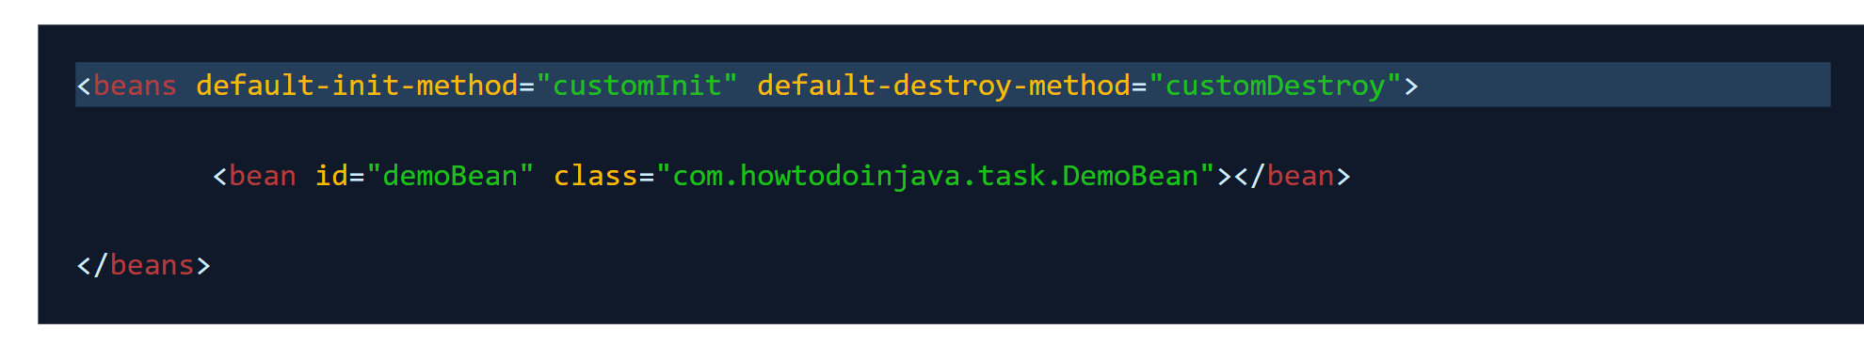

### **@PostConstruct and @PreDestroy**

### Spring 2.5 onwards, you can use annotations also for specifying life cycle methods using @PostConstruct and @PreDestroy annotations.

### @PostConstruct annotated method will be invoked after the bean has been constructed using default constructor and just before it’s instance is returned to requesting object.

### @PreDestroy annotated method is called just before the bean is about be destroyed inside bean container.

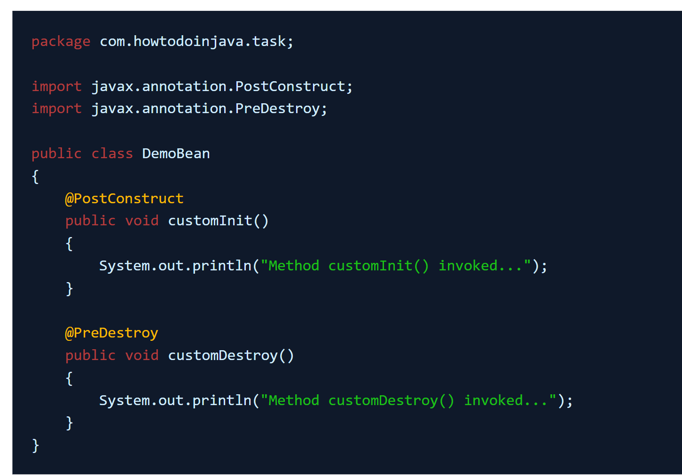

## Sequence of lifecycle methods?

### Multiple lifecycle mechanisms configured for the same bean, with different initialization methods, are called in below mentioned order:

### • Methods annotated with @PostConstruct

### • afterPropertiesSet() as defined by the InitializingBean callback interface

### • A custom configured init() method

### Destroy methods are called in the same order:

### • Methods annotated with @PreDestroy

### • destroy() as defined by the DisposableBean callback interface

### • A custom configured destroy() method

## Example of beanPostProcessor?

### @Autowired, @Inject, @Resource, and @Value annotations are handled by Spring BeanPostProcessor implementations which in turn means that you *cannot* apply these annotations within your own BeanPostProcessor or BeanFactoryPostProcessor types (if any). These types must be 'wired up' explicitly via XML or using a Spring @Bean method.

## BeanPostProcessor?

### Spring provides the  BeanPostProcessor interface that gives you the means to tap into the Spring context life cycle and interact with beans as they are processed. The BeanPostProcessor interface contains two methods.

### **postProcessBeforeInitialization**: Spring calls this method after calling the methods of the aware interfaces and before any bean initialization callbacks, such as InitializingBean’s afterPropertiesSetor a custom init-method.

### **postProcessAfterInitialization**: Spring calls this method after any bean initialization callbacks.

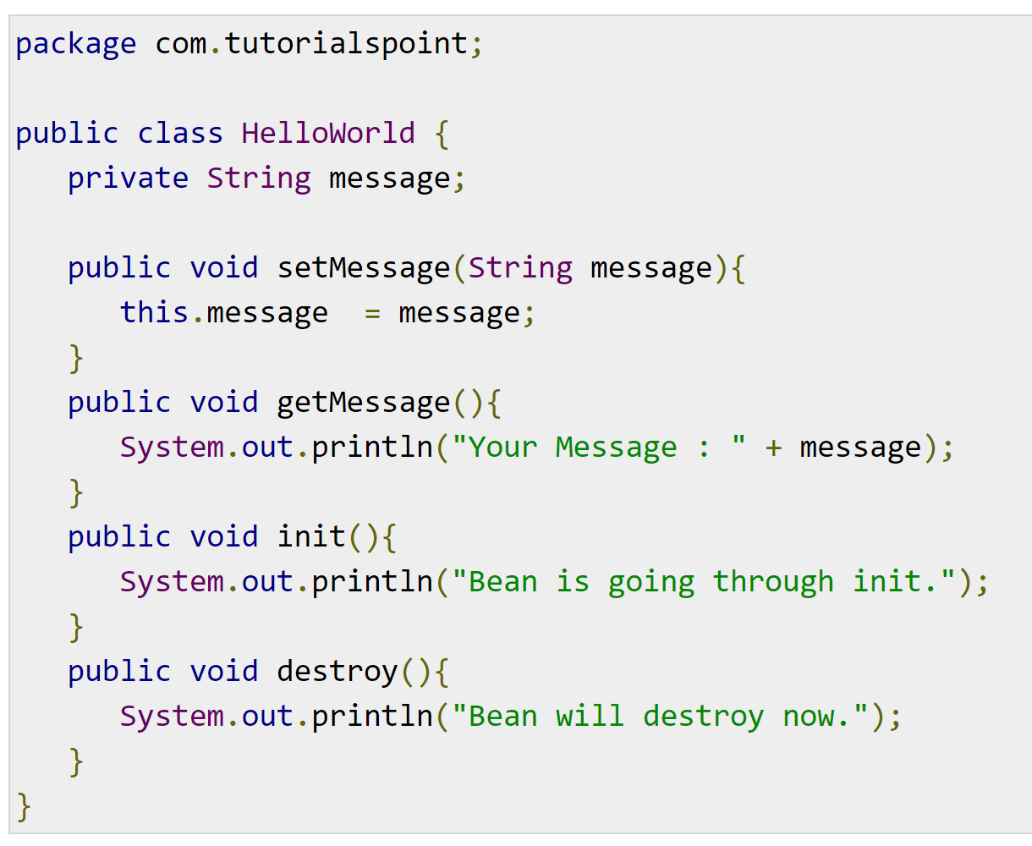

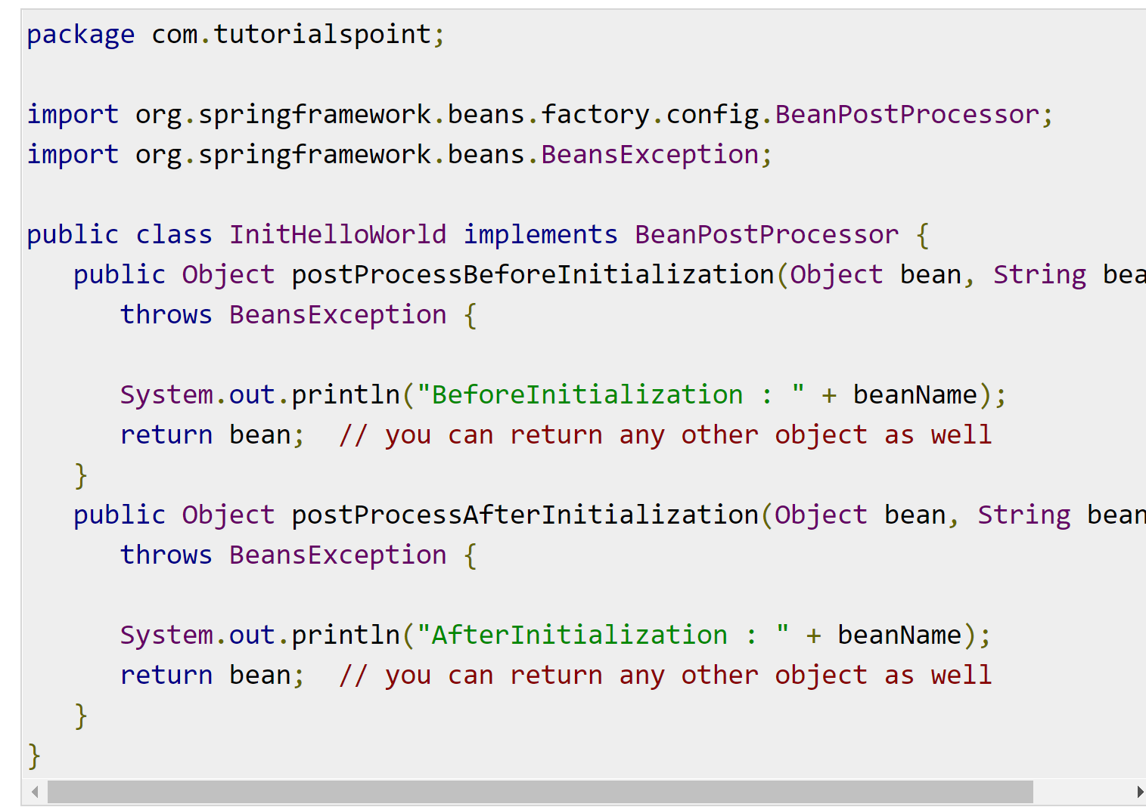

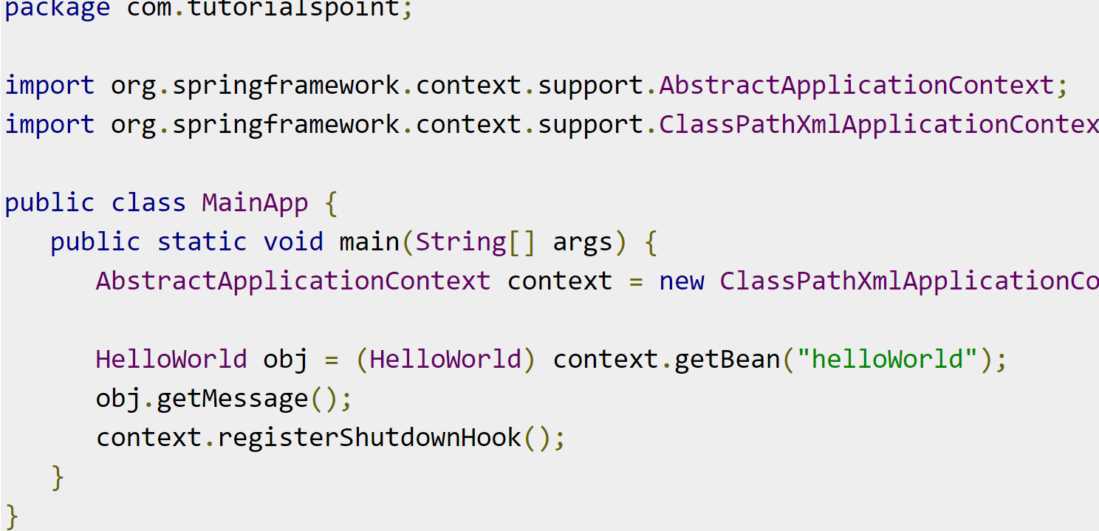

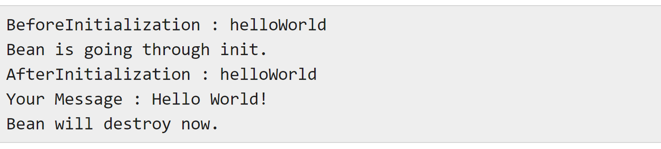

## How to register beans that are not created by Spring?

### ApplicationContext implementations also permit the registration of existing objects that are created outside the container, by users. This is done by accessing the ApplicationContext’s BeanFactory via the method getBeanFactory() which returns the BeanFactory implementation DefaultListableBeanFactory. DefaultListableBeanFactory supports this registration through the methods registerSingleton(..) and registerBeanDefinition(..). However,typical applications work solely with beans defined through metadata bean definitions.

<https://www.logicbig.com/tutorials/spring-framework/spring-core/bean-definition.html>

## What is BeanDefiniton?

### A Spring IoC container manages one or more *beans*. These beans are created with the configuration metadata that you supply to the container, for example, in the form of XML <bean/> definitions.Within the container itself, these bean definitions are represented as BeanDefinition objects, which contain (among other information) the following metadata:

### *A package-qualified class name:* typically the actual implementation class of the bean being defined.

### • Bean behavioral configuration elements, which state how the bean should behave in the container

### (scope, lifecycle callbacks, and so forth).

### • References to other beans that are needed for the bean to do its work; these references are also called *collaborators* or *dependencies*.

### • Other configuration settings to set in the newly created object, for example, the number of connections to use in a bean that manages a connection pool, or the size limit of the pool.

### This metadata translates to a set of properties that make up each bean definition.

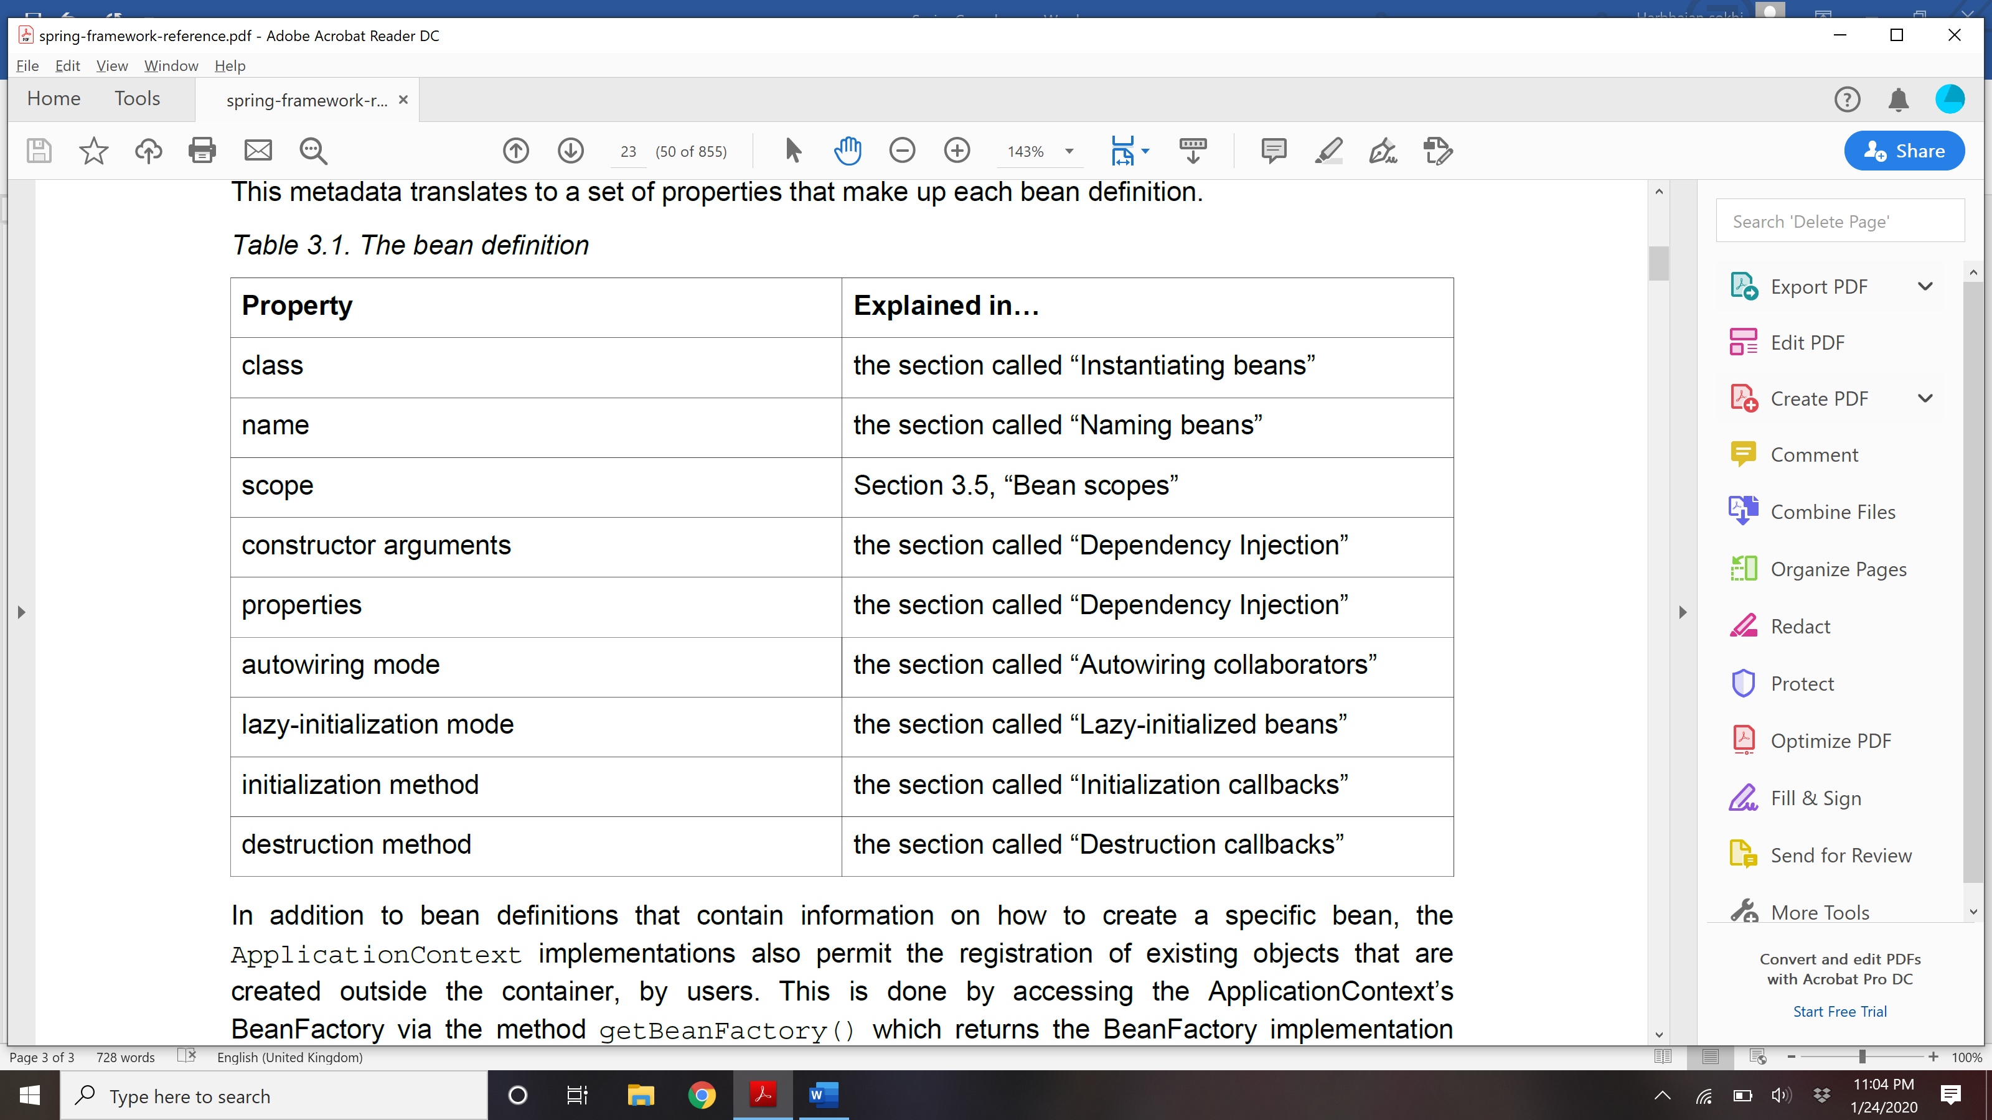

## Bean definition inheritance

### A bean definition can contain a lot of configuration information, including constructor arguments, property values, and container-specific information such as initialization method, static factory method name, and so on.

### A child bean definition inherits configuration data from a parent definition. The child definition can override some values, or add others, as needed.

### A child bean definition uses the bean class from the parent definition if none is specified, but can also override it. In the latter case, the child bean class must be compatible with the parent, that is, it must

### accept the parent’s property values.

### A child bean definition inherits scope, constructor argument values, property values, and method overrides from the parent, with the option to add new values. Any scope, initialization method, destroymethod, and/or static factory method settings that you specify will override the corresponding parent settings.

### The remaining settings are *always* taken from the child definition: *depends on*, *autowire mode*,*dependency check*, *singleton*, *lazy init*.

In the below method, child bean inherit message 2 from parent bean and add a new property called message3 for itself.

<bean id = "helloWorld" class = "com.tutorialspoint.HelloWorld">

<property name = "message1" value = "Hello World!"/>

<property name = "message2" value = "Hello Second World!"/>

</bean>

<bean id ="helloIndia" class = "com.tutorialspoint.HelloIndia" parent = "helloWorld">

<property name = "message1" value = "Hello India!"/>

<property name = "message3" value = "Namaste India!"/>

</bean>

## How spring instantiate beans?

### If you use XML-based configuration metadata, you specify the type (or class) of object that is to be instantiated in the class attribute of the <bean/> element. This class attribute, which internally is a Class property on a BeanDefinition instance, is usually mandatory. (For exceptions, see the section called “Instantiation using an instance factory method” and Section 3.7, “Bean definition inheritance”.)

### You use the Class property in one of two ways:

### • Typically, to specify the bean class to be constructed in the case where the container itself directly creates the bean by calling its constructor reflectively, somewhat equivalent to Java code using the new operator.

### • To specify the actual class containing the static factory method that will be invoked to create the object, in the less common case where the container invokes a static *factory* method on a class to create the bean. The object type returned from the invocation of the static factory method may be the same class or another class entirely.

### **Instantiation with a constructor**

### **<bean id**=**"exampleBean" class**=**"examples.ExampleBean"/>**

### **<bean name**=**"anotherExample" class**=**"examples.ExampleBeanTwo"/>**

### **Instantiation with a static factory method**

### **<bean id**=**"clientService"**

### **class**=**"examples.ClientService"**

### **factory-method**=**"createInstance"/>**

### **public class** ClientService {

### **private static** ClientService clientService = **new** ClientService();

### **private** ClientService() {}

### **public static** ClientService createInstance() {

### **return** clientService;

### }

### }

### **Instantiation using an instance factory method**

### To use this mechanism, leave the class attribute empty, and in the factory-bean attribute, specify the name of a bean in the current (or parent/ancestor) container that contains the instance method that is to be invoked to create the object. Set the name of the factory method itself with the factory-method attribute.

### *<!-- the factory bean, which contains a method called createInstance() -->*

### **<bean id**=**"serviceLocator" class**=**"examples.DefaultServiceLocator">**

### *<!-- inject any dependencies required by this locator bean -->*

### **</bean>**

### *<!-- the bean to be created via the factory bean -->*

### **<bean id**=**"clientService"**

### **factory-bean**=**"serviceLocator"**

### **factory-method**=**"createClientServiceInstance"/>**

### **public class** DefaultServiceLocator {

### **private static** ClientService clientService = **new** ClientServiceImpl();

### **private** DefaultServiceLocator() {}

### **public** ClientService createClientServiceInstance() {

### **return** clientService;

### }

### }

## Lazy Initialization of Beans?

### By default, ApplicationContext implementations eagerly create and configure all singleton beansas part of the initialization process. Generally, this pre-instantiation is desirable, because errors in the configuration or surrounding environment are discovered immediately, as opposed to hours or even days later. When this behavior is *not* desirable, you can prevent pre-instantiation of a singleton bean by marking the bean definition as lazy-initialized.

### A lazy-initialized bean tells the IoC container to create a

### bean instance when it is first requested, rather than at startup.

### In XML, this behavior is controlled by the lazy-init attribute on the <bean/> element; for example:

### **<bean id**=**"lazy" class**=**"com.foo.ExpensiveToCreateBean" lazy-init**=**"true"/>**

### **<bean name**=**"not.lazy" class**=**"com.foo.AnotherBean"/>**

### When the preceding configuration is consumed by an ApplicationContext, the bean named lazy is not eagerly pre-instantiated when the ApplicationContext is starting up, whereas the not.lazy

### bean is eagerly pre-instantiated.

### **However, when a lazy-initialized bean is a dependency of a singleton bean that is *not* lazy-initialized, the ApplicationContext creates the lazy-initialized bean at startup, because it must satisfy the**

### **singleton’s dependencies. The lazy-initialized bean is injected into a singleton bean elsewhere that is not lazy-initialized.**

### You can also control lazy-initialization at the container level by using the default-lazy-init attribute on the <beans/> element; for example:

### **<beans default-lazy-init**=**"true">**

### *<!-- no beans will be pre-instantiated... -->*

### **</beans>**

## Explain refBean, collection, property etc in XML way of defining configuration?

**Constructor :**

**<bean id**=**"exampleBean" class**=**"examples.ExampleBean">**

**<constructor-arg type**=**"int" value**=**"7500000"/>**

**<constructor-arg type**=**"java.lang.String" value**=**"42"/>**

**</bean>**

**For same type:**

<bean id="exampleBean" class="examples.ExampleBean">

<constructor-arg index="0" value="7500000"/>

<constructor-arg index="1" value="42"/>

</bean>

Giving name for ambiguity:

**<bean id**=**"exampleBean" class**=**"examples.ExampleBean">**

**<constructor-arg name**=**"years" value**=**"7500000"/>**

**<constructor-arg name**=**"ultimateAnswer" value**=**"42"/>**

**</bean>**

**Setter DI:**

**<bean id**=**"exampleBean" class**=**"examples.ExampleBean">**

*<!-- setter injection using the nested ref element -->*

**<property name**=**"beanOne">**

**<ref bean**=**"anotherExampleBean"/>**

**</property>**

*<!-- setter injection using the neater ref attribute -->*

**<property name**=**"beanTwo" ref**=**"yetAnotherBean"/>**

**<property name**=**"integerProperty" value**=**"1"/>**

**</bean>**

**<bean id**=**"anotherExampleBean" class**=**"examples.AnotherBean"/>**

**<bean id**=**"yetAnotherBean" class**=**"examples.YetAnotherBean"/>**

Constructor with ref bean:

**<bean id**=**"exampleBean" class**=**"examples.ExampleBean">**

*<!-- constructor injection using the nested ref element -->*

**<constructor-arg>**

**<ref bean**=**"anotherExampleBean"/>**

**</constructor-arg>**

*<!-- constructor injection using the neater ref attribute -->*

**<constructor-arg ref**=**"yetAnotherBean"/>**

**<constructor-arg type**=**"int" value**=**"1"/>**

**</bean>**

**<bean id**=**"anotherExampleBean" class**=**"examples.AnotherBean"/>**

**<bean id**=**"yetAnotherBean" class**=**"examples.YetAnotherBean"/>**

**Util properties:**

**<bean id**=**"mappings"**

**class**=**"org.springframework.beans.factory.config.PropertyPlaceholderConfigurer">**

*<!-- typed as a java.util.Properties -->*

**<property name**=**"properties">**

**<value>**

jdbc.driver.className=com.mysql.jdbc.Driver

jdbc.url=jdbc:mysql://localhost:3306/mydb

**</value>**

**</property>**

**</bean>**

**Also read about idref, innerbean, collection, parent bean, nul and empty string, depende-on**

## Explain autowiring

### Autowiring lets you get rid of explicit wiring definition in the beans.xml here by reduce lot of boiler plate code.

### The Spring container can *autowire* relationships between collaborating beans. You can allow Spring to resolve collaborators (other beans) automatically for your bean by inspecting the contents of the ApplicationContext.

### Autowiring has the following advantages:

### • Autowiring can significantly reduce the need to specify properties or constructor arguments.

### • Autowiring can update a configuration as your objects evolve. For example, if you need to add a dependency to a class, that dependency can be satisfied automatically without you needing to modify the configuration. Thus autowiring can be especially useful during development, without negating the

### option of switching to explicit wiring when the code base becomes more stable.

### When using XML-based configuration metadata 10, you specify autowire mode for a bean definition with the autowire attribute of the <bean/> element. The autowiring functionality has four modes. You specify autowiring *per* bean and thus can choose which ones to autowire.

### Mode Explanation

### **no (Default)** No autowiring. Bean references must be defined via a ref element. Changing the default setting is not recommended for larger deployments, because specifying collaborators explicitly gives greater control and clarity. To some extent, it documents the structure of a

### system.

### **byName** Autowiring by property name. Spring looks for a bean with the same name as the property that needs to be autowired. For example, if a

### bean definition is set to autowire by name, and it contains a *master* property (that is, it has a *setMaster(..)* method), Spring looks for a bean definition named master, and uses it to set the property.

### In Spring, “**Autowiring by Name**” means, if the name of a bean is same as the name of other bean property, auto wire it.

### For example, if a “customer” bean exposes an “address” property, Spring will find the “address” bean in current container and wire it automatically. And if no matching found, just do nothing.

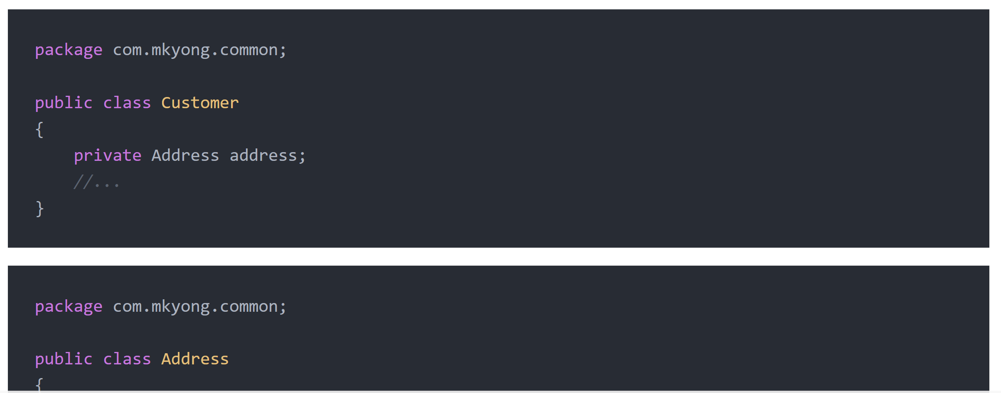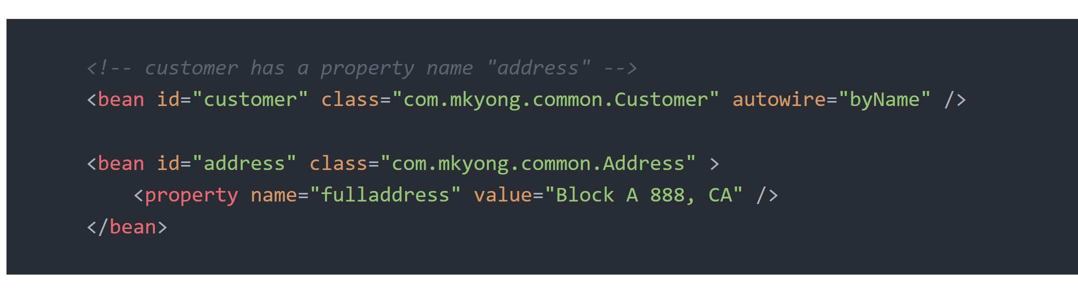

### **byType** Allows a property to be autowired if exactly one bean of the property type exists in the container.If more than one exists, a fatal exception is

### thrown, which indicates that you may not use *byType* autowiring for that bean. *If there are no matching beans, nothing happens; the property*

### *is not set.*

### **constructor** Analogous to *byType*, but applies to constructor arguments. If there is not exactly one bean of the constructor argument type in the container, a fatal error is raised.

** autodetect mode is deprecated and no longer in use.

### **Autodetect**: this is deprecated. Autowiring by autodetect uses two modes, i.e.constructor or byType modes. First, it will look for valid constructor with arguments. If it is found, then the constructor mode is chosen. If there is no constructor defined in a bean, the autowire byType mode is chosen.

<bean id="employee" class="guru.springframework.autowiringdemo.Employee" autowire="autodetect"></bean>

## disadvantages and limitation of autowiring

### 1) Explicit dependencies in property and constructor-arg settings always override autowiring..

### 2) Autowiring is less exact than explicit wiring. Although, as noted in the above table, Spring is careful to avoid guessing in case of ambiguity that might have unexpected results, the relationships between

### your Spring-managed objects are no longer documented explicitly.

### 3) Multiple bean definitions within the container may match the type specified by the setter method or constructor argument to be autowired.

## How to exclude autowiring:

### autowire-candidate = false on bean

### default-autowire-candidates= fasle on top of bean declaration

## Default autowiring modes?

### The default autowire mode in XML configuration is no.

### The default autowire mode in java configuration is byType.

The default autowire mode in Annotation based is depened on where you are using @Autowired. @ Autowire can be used on property, setter and constructor. For property and setter, mode is byType and for constructor the mode is constructor.

## What is error safe autowiring.

@Autowire is a way of autowiring in annotation based approach.

### Even if you have used utmost care in autowiring bean dependencies, still you may find strange lookup failures. So, solve this issue, you will need to make autowiring optional so that if no dependency is found, application should not throw any exception and autowiring should simply be ignored.

### This can be done in two ways:

### If you want to make specific bean **autowiring non-mandatory for a specific bean property**, use **required=”false”** attribute in @Autowired annotation.

|  |
| --- |
| EmployeeBean.java |
| @Autowired (required=false)@Qualifier ("finance")private DepartmentBean departmentBean; |

### If you want to apply **optional autowiring at global level** i.e. for all properties in all beans; use below configuration setting.

|  |
| --- |
| beans.xml |
| <bean class="org.springframework.beans.factory.annotation.AutowiredAnnotationBeanPostProcessor">    <property name="requiredParameterValue" value="false" /></bean> |

For local level at bean use – autowire-candidate=false

## How to handle error when multiple beans found with same type.

### Use @Primary or @Qualifier

## @ Primary

### Because autowiring by type may lead to multiple candidates, it is often necessary to have more control over the selection process. One way to accomplish this is with Spring’s @Primary annotation.

### @Primary indicates that a particular bean should be given preference when multiple beans are candidates to be autowired to a single-valued dependency. If exactly one 'primary' bean exists among the candidates, it will be the autowired value.

@Primary means default.

### @Configuration

### **public class** MovieConfiguration {

### @Bean

### **@Primary**

### **public** MovieCatalog firstMovieCatalog() { ... }

### @Bean

### **public** MovieCatalog secondMovieCatalog() { ... }

### *// ...*

### }

### With such configuration, the following MovieRecommender will be autowired with the

### firstMovieCatalog.

## @Qualifier vs @ Primary

### Read [@Primary](https://docs.spring.io/spring-framework/docs/current/javadoc-api/org/springframework/context/annotation/Primary.html) as the "default".

### If a bean has @Autowired *without* any @Qualifier, and multiple beans of the type exist, the candidate bean marked @Primary will be chosen, i.e. it is the default selection when no other information is available, i.e. when @Qualifier is missing.

### A good use case is that initially you only had one bean of the type, so none of the code used @Qualifier. When you then add another bean, you then also add @Qualifier to both the old and the new bean, so any @Autowired can choose which one it wants. By also adding @Primary to the old original bean, you don't have to add @Qualifier to all the existing @Autowired. They are "grandfathered" in, so to speak.

## @Qualifier

In Spring, @Qualifier means, which bean is qualify to autowired on a field. See following scenario :

See below example, it will autowired a “person” bean into customer’s person property.

package com.mkyong.common;

import org.springframework.beans.factory.annotation.Autowired;

import org.springframework.beans.factory.annotation.Qualifier;

public class Customer {

@Autowired

private Person person;

//...

}

Copy

But, two similar beans “com.mkyong.common.Person” are declared in bean configuration file. Will Spring know which person bean should autowired?

<beans xmlns="http://www.springframework.org/schema/beans"

xmlns:xsi="http://www.w3.org/2001/XMLSchema-instance"

xsi:schemaLocation="http://www.springframework.org/schema/beans

http://www.springframework.org/schema/beans/spring-beans-2.5.xsd">

<bean

class ="org.springframework.beans.factory.annotation.AutowiredAnnotationBeanPostProcessor"/>

<bean id="customer" class="com.mkyong.common.Customer" />

<bean id="personA" class="com.mkyong.common.Person" >

<property name="name" value="mkyongA" />

</bean>

<bean id="personB" class="com.mkyong.common.Person" >

<property name="name" value="mkyongB" />

</bean>

</beans>

Copy

When you run above example, it hits below exception :

Caused by: org.springframework.beans.factory.NoSuchBeanDefinitionException:

No unique bean of type [com.mkyong.common.Person] is defined:

expected single matching bean but found 2: [personA, personB]

Copy

To fix above problem, you need **@Quanlifier** to tell Spring about which bean should autowired.

package com.mkyong.common;

import org.springframework.beans.factory.annotation.Autowired;

import org.springframework.beans.factory.annotation.Qualifier;

public class Customer {

@Autowired

@Qualifier("personA")

private Person person;

//...

}

Copy

In this case, bean “personA” is autowired.

Customer [person=Person [name=mkyongA]]

## @Resource vs @Inject vs @Autowire

### Resource and inject are JSR specification while Autowire is spring specification

### The behaviour of @Autowired annotation is similar to the @Inject annotation. The only difference is that the @Autowired annotation is part of the Spring framework. This annotation has the same execution paths as the @Inject annotation, listed in order of precedence:

### Match by Type

### Match by Qualifier

### Match by Name

### These execution paths are applicable to both setter and field injection.

### The @Resource annotation is part of the [JSR-250](https://jcp.org/en/jsr/detail?id=250) annotation collection and is packaged with Jakarta EE. This annotation has the following execution paths, listed by precedence:

### Match by Name

### Match by Type

### Match by Qualifier

### These execution paths are applicable to both setter and field injection.

## What is autodetect?

### Spring can automatically detect stereotyped classes and register corresponding BeanDefinitions with the ApplicationContext. For example, the following two classes are eligible for such autodetection:

### @Service

### public class SimpleMovieLister {

### private MovieFinder movieFinder;

### @Autowired

### public SimpleMovieLister(MovieFinder movieFinder) {

### this.movieFinder = movieFinder;

### }

### }

### @Repository

### public class JpaMovieFinder implements MovieFinder {

### // implementation elided for clarity

### }

### **To autodetect these classes and register the corresponding beans, you need to add @ComponentScan to your @Configuration class**, where the basePackages attribute is a common parent package for the two classes. (Alternatively, you can specify a comma/semicolon/space-separated list that includes

### the parent package of each class.)

### @Configuration

### @ComponentScan(basePackages = "org.example")

### public class AppConfig {

### ...

### }

### Note

### for concision, the above may have used the value attribute of the annotation, i.e.

### @ComponentScan("org.example")

### The following is an alternative using XML

### <?xml version="1.0" encoding="UTF-8"?>

### <beans >

### <context:component-scan base-package="org.example"/>

### </beans>

### **By default, classes annotated with @Component, @Repository, @Service, @Controller, or a custom annotation that itself is annotated with @Component are the only detected candidate components. However, you can modify and extend this behavior simply by applying custom filters. Add**

### **them as includeFilters or excludeFilters parameters of the @ComponentScan annotation (or as includefilter or exclude-filter sub-elements of the component-scan element).**

### Each filter element requires the type and expression attributes. The following table describes the filtering options.

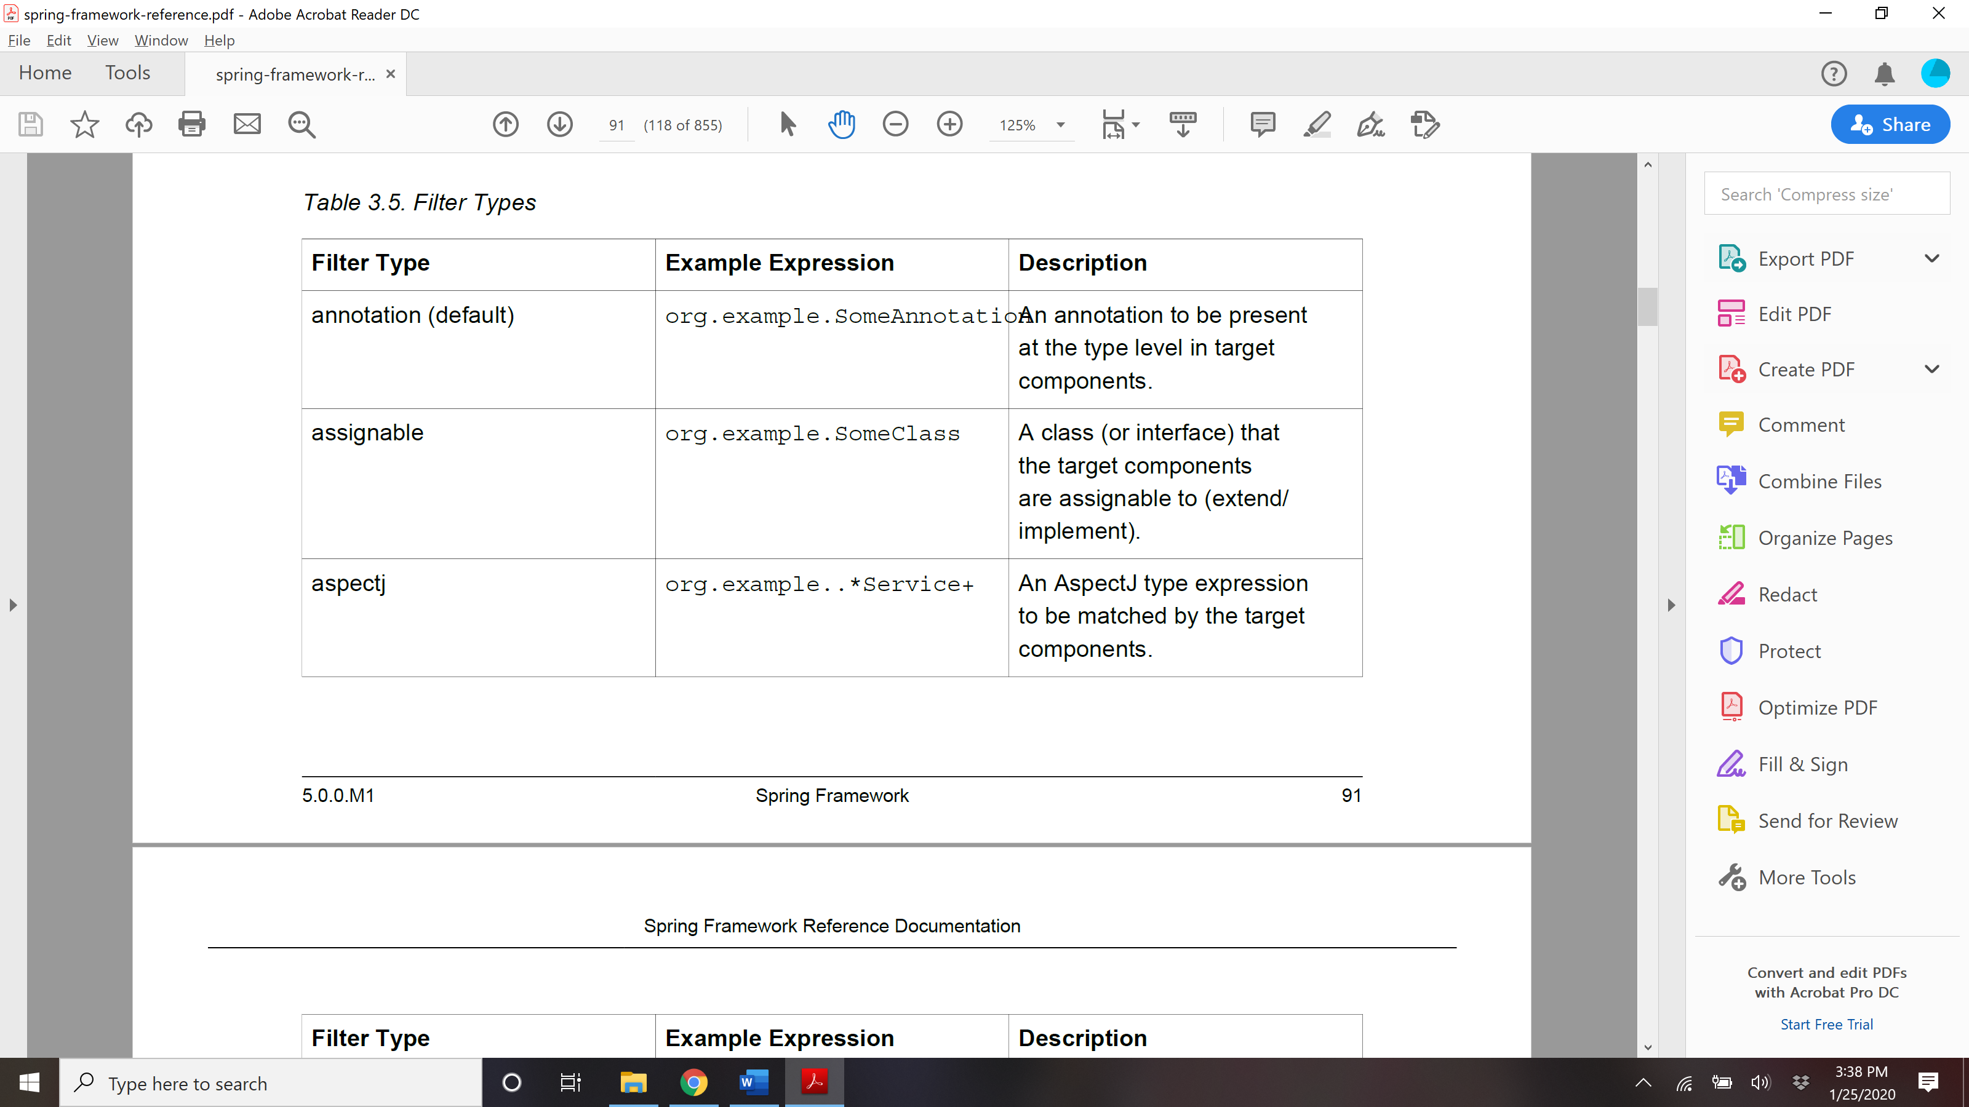

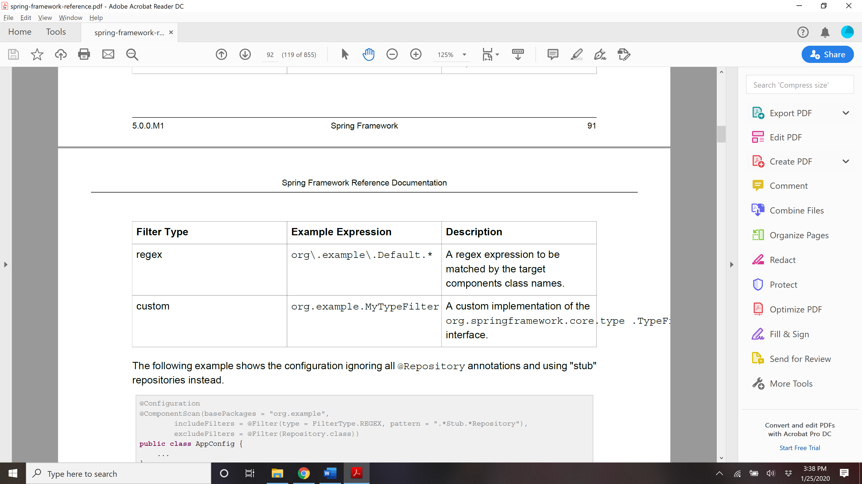

## **@Named: a standard equivalent to the @Component annotation**

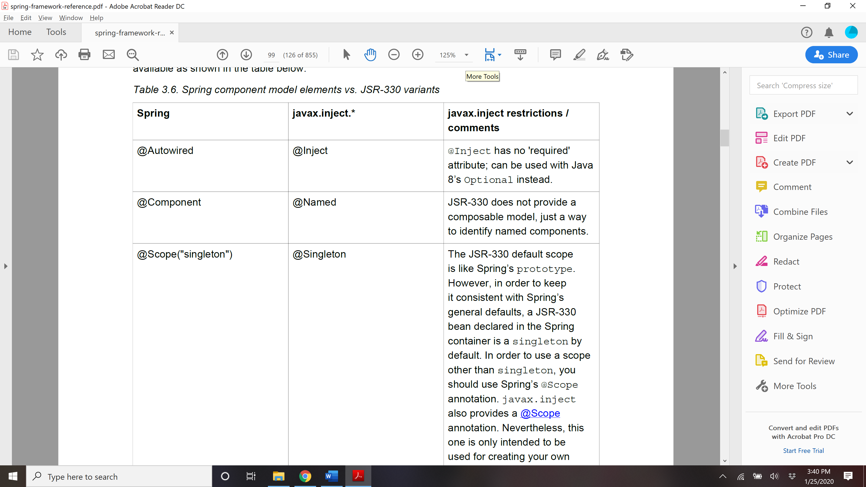

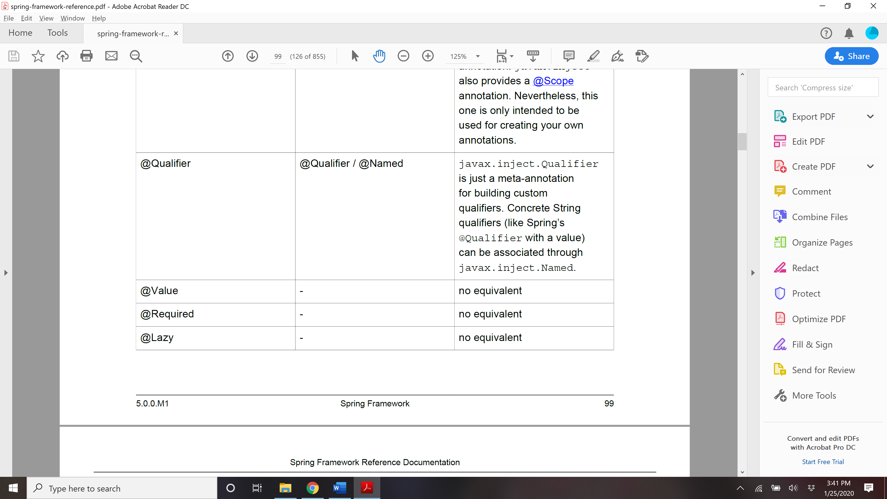

## @Bean and @ Configuration?

### The central artifacts in Spring’s new Java-configuration support are @Configuration-annotated classes and @Bean-annotated methods.

### The @Bean annotation is used to indicate that a method instantiates, configures and initializes a new object to be managed by the Spring IoC container. For those familiar with Spring’s <beans/> XML configuration the @Bean annotation plays the same role as the <bean/> element. You can use

### @Bean annotated methods with any Spring @Component, however, they are most often used with @Configuration beans.

### Annotating a class with @Configuration indicates that its primary purpose is as a source of bean definitions. Furthermore, @Configuration classes allow inter-bean dependencies to be defined by simply calling other @Bean methods in the same class. The simplest possible @Configuration class

### would read as follows:

@Configuration

**public class** AppConfig {

@Bean

**public** MyService myService() {

**return new** MyServiceImpl();

}

}

### The AppConfig class above would be equivalent to the following Spring <beans/> XML:

**<beans>**

**<bean id**=**"myService" class**=**"com.acme.services.MyServiceImpl"/>**

**</beans>**

## Full @Configuration vs 'lite' @Beans mode?

### When @Bean methods are declared within classes that are *not* annotated with @Configuration they are referred to as being processed in a 'lite' mode. For example, bean methods declared in a @Component or even in a *plain old class* will be considered 'lite'.

### Unlike full @Configuration, **lite @Bean methods cannot easily declare inter-bean dependencies**. Usually one @Bean method should not invoke another @Bean method when operating in 'lite' mode.

### Only using @Bean methods within @Configuration classes is a recommended approach of ensuring that 'full' mode is always used. This will prevent the same @Bean method from accidentally being invoked multiple times and helps to reduce subtle bugs that can be hard to track down when operating in 'lite' mode

## Difference between @Component and @Bean

471

### @Component and @Bean do two quite different things, and shouldn't be confused.

### @Component (and @Service and @Repository) are used to auto-detect and auto-configure beans using classpath scanning. There's an implicit one-to-one mapping between the annotated class and the bean (i.e. one bean per class). Control of wiring is quite limited with this approach, since it's purely declarative.

### @Bean is used to *explicitly* declare a single bean, rather than letting Spring do it automatically as above. It decouples the declaration of the bean from the class definition, and lets you create and configure beans exactly how you choose.

### To answer your question...

### would it have been possible to re-use the @Component annotation instead of introducing @Bean annotation?

### Sure, probably; but they chose not to, since the two are quite different. Spring's already confusing enough without muddying the waters further.

## AnnotationConfigApplicationContext

Used for instantiating ApplicationContext for java based/annotation based files.

**public static void** main(String[] args) {

ApplicationContext ctx = **new** AnnotationConfigApplicationContext(AppConfig.**class**);

MyService myService = ctx.getBean(MyService.**class**);

myService.doStuff();

}

**public static void** main(String[] args) {

ApplicationContext ctx = **new** AnnotationConfigApplicationContext(MyServiceImpl.**class**,

Dependency1.**class**, Dependency2.**class**);

MyService myService = ctx.getBean(MyService.**class**);

myService.doStuff();

}

**public static void** main(String[] args) {

AnnotationConfigApplicationContext ctx = **new** AnnotationConfigApplicationContext();

ctx.register(AppConfig.**class**, OtherConfig.**class**);

ctx.register(AdditionalConfig.**class**);

ctx.refresh();

MyService myService = ctx.getBean(MyService.**class**);

myService.doStuff();

}

## How can we instantiate ApplicationContext?

ApplicationContext is an interface which provides multiple implementation for different use. The mostly used methods are as follows-

### **FileSystemXMLApplicationContext** : We use the [FileSystemXMLApplicationContext](https://docs.spring.io/spring-framework/docs/current/javadoc-api/org/springframework/context/support/FileSystemXmlApplicationContext.html)class to **load an XML-based Spring configuration file from the file system** or from URLs. This class is useful when we need to load the ApplicationContext programmatically. In general, test harnesses and standalone applications are some of the possible use cases for this.

### For example, let's see how we can create this Spring container and load the beans for our XML-based configuration:

String path = "C:/myProject/src/main/resources/applicationcontext/account-bean-config.xml";

ApplicationContext context = **new** FileSystemXmlApplicationContext(path);

AccountService accountService = context.getBean("accountService", AccountService.class);

### **ClassPathXmlApplicationContext**: In case we want to **load an XML configuration file from the classpath**, we can use the [ClassPathXmlApplicationContext](https://docs.spring.io/spring-framework/docs/current/javadoc-api/org/springframework/context/support/ClassPathXmlApplicationContext.html) class. Similar to FileSystemXMLApplicationContext, it's useful for test harnesses as well as for application contexts embedded within JARs.

### So, let's see an example of using this class:

ApplicationContext context = **new** ClassPathXmlApplicationContext("applicationcontext/account-bean-config.xml");

AccountService accountService = context.getBean("accountService", AccountService.class);

### **AnnotationConfigApplicationContext**: Standalone application context, accepting annotated classes as input - in particular [@Configuration](https://docs.spring.io/spring-framework/docs/3.0.0.RELEASE/javadoc-api/org/springframework/context/annotation/Configuration.html)-annotated classes, but also plain [@Components](https://docs.spring.io/spring-framework/docs/3.0.0.RELEASE/javadoc-api/org/springframework/stereotype/Component.html) and JSR-330 compliant classes using javax.inject annotations. Allows for registering classes one by one ([register(java.lang.Class...)](https://docs.spring.io/spring-framework/docs/3.0.0.RELEASE/javadoc-api/org/springframework/context/annotation/AnnotationConfigApplicationContext.html#register(java.lang.Class...))) as well as for classpath scanning ([scan(java.lang.String...)](https://docs.spring.io/spring-framework/docs/3.0.0.RELEASE/javadoc-api/org/springframework/context/annotation/AnnotationConfigApplicationContext.html#scan(java.lang.String...))).

### In case of multiple Configuration classes, [Bean](https://docs.spring.io/spring-framework/docs/3.0.0.RELEASE/javadoc-api/org/springframework/context/annotation/Bean.html) methods defined in later classes will override those defined in earlier classes. This can be leveraged to deliberately override certain bean definitions via an extra Configuration class.

ApplicationContext context = **new** AnnotationConfigApplicationContext(AccountConfig.class); AccountService accountService = context.getBean(AccountService.class);

## Component scan

### @ComponentScan annotation enables component scanning in Spring. Java classes that are decorated with stereotypes such as @Component, @Configuration, @Service are auto-detected by Spring. The @ComponentScan's basePackages attribute specifies which packages should be scanned for decorated beans.

### The @ComponentScan annotation is an alternative to <context:component-scan> XML tag.

### To enable component scanning, just annotate your @Configuration class as follows:

### @Configuration

### @ComponentScan(basePackages = "com.acme")

### public class AppConfig {

### ...

### }

### Tip

### Experienced Spring users will be familiar with the XML declaration equivalent from Spring’s

### context: namespace

### <beans>

### <context:component-scan base-package="com.acme"/>

### </beans>

## Annotation for @Bean

### @Bean(name =xx, initMethod = yy, destroyMethod=zz , autowire=Autowire.YES)

### @Scope

### @Descrciption()

### @Lazy

### Public void getMyBean(){};

## Import in java based config?

@Configuration

**public class** ConfigA {

@Bean

**public** A a() {

**return new** A();

}

}

@Configuration

@Import(ConfigA.class)

**public class** ConfigB {

@Bean

**public** B b() {

**return new** B();

}

}

## @Conditional

### The @Conditional annotation indicates that a component is only registered into the application context when all the specified conditions match. In Spring 4 @Conditional annotation has been added which can be used for providing your own logic for conditional checking and then decide whether specific bean should be registered or not.

### Spring provides plenty of conditional annotations out-of-the-box, including @ConditionalOnClass, @ConditionalOnMissingBean, @ConditionalOnBean, @ConditionalOnProperty, @ConditionalOnNotWebApplication, and @ConditionalOnExpression.

### The @Conditional annotation indicates specific **org.springframework.context.annotation.Condition** implementations that specifies the condition which should be consulted before a @Bean is registered.

## Difference between @Conditional and @Profile

@Profile is used for property only whereas Conditional is generic and more powerful and can be used for proerety, class, bean, object and so on.

## @DependsOn

### The annotation [DependsOn](http://docs.spring.io/spring/docs/current/javadoc-api/org/springframework/context/annotation/DependsOn.html) specifies (as it's String[] value() element) one or more beans to be loaded before this bean. We want to use this annotation when beans do not directly has references of each others but still depends on each other in some ways. Letting them initialize randomly by the Spring container might results in side effects.

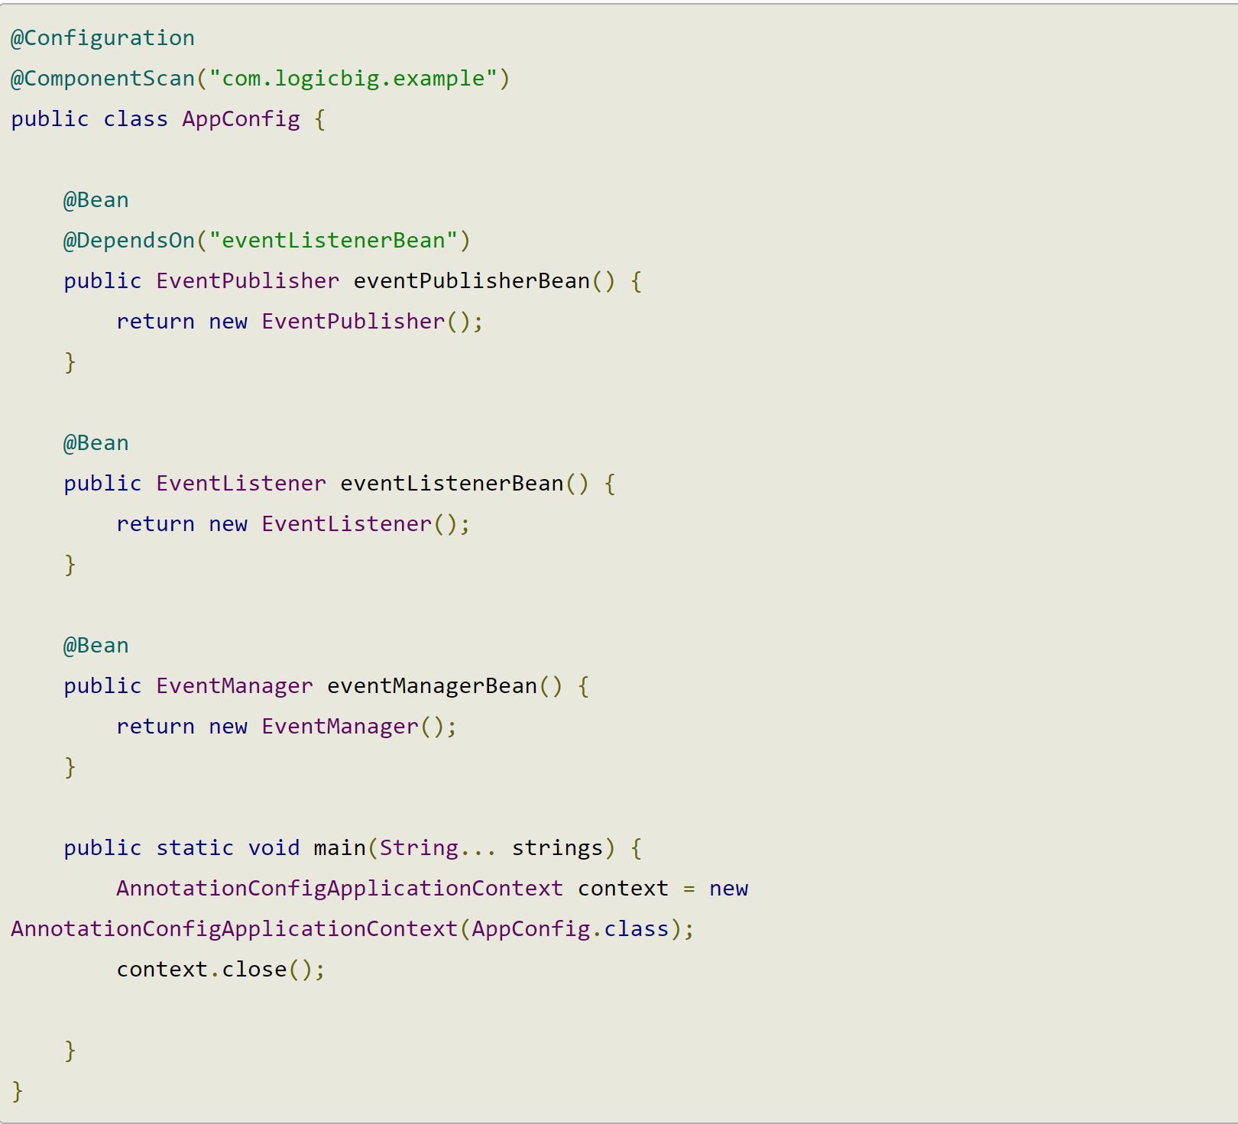

eventListenerBean will be loaded first and then eventPublisherBean is loaded.

SPRING additional functionalities

## How to read property from properties file?

There are multiple ways to read file:

### @**ConfigurationProperties** is to map properties with POJO beans. Then you could use bean to access the properties values inn your application.

### @**PropertySource** is to reference a properties file and load it.

### @**Value** is to inject a particular property value by it's key.

### @**Value annotation :** this is the simplest way to read property file in spring boot (check for spring) from application.properties file. Define property in application.properties for example project.name = myProject and inject directly in the code.

@Component

public class ProjectDetails {

@Value("${project.name}")

private String projectName;

}

**@Value throw exception, if property not found in the file.**

### @**PropertyResource**: To read property from a file , A way to define external property file. This is repeatable annotation. We can use multiple annotation on single class.

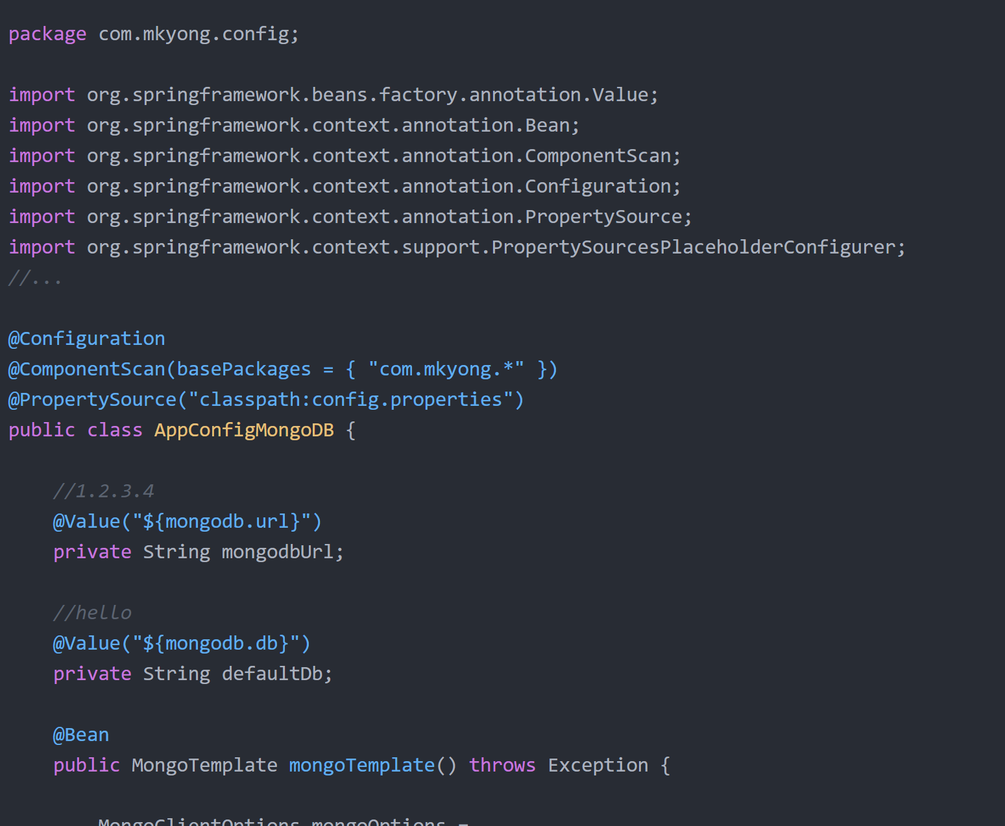

### **ConfigurationProperties**: This map propertyfile to POJO and does not throw exception if no key is found. Using the @Value("${property.name}") annotation to inject configuration properties can sometimes be cumbersome, especially if you are working with multiple properties or your data is hierarchical in nature. Spring Boot provides an alternative method of working with properties that allows strongly typed beans to govern and validate the configuration of your application.

### **Relaxed binding**

### Spring Boot automatically uses relaxed rules for binding Environment properties to @ConfigurationProperties beans. Meaning, there doesn’t need to be an exact match between the Environment property name and the bean property name. Imagine you have a bean property called allowCredentials you can use the following configuration in your properties.

### **allowCredentials**: using standard camel case syntax.

### **allow-credentials**: using dashed notation.

### **allow_credentials**: using underscore notation.

### **ALLOW_CREDENTIALS**: using upper case format.

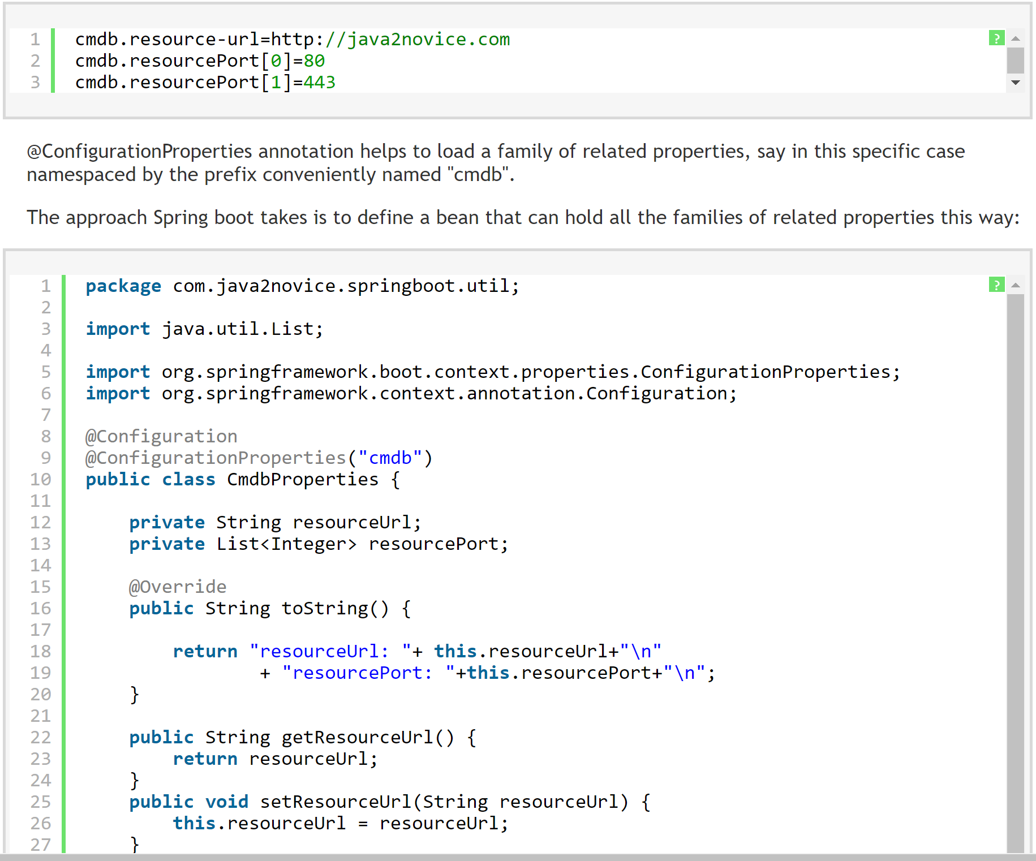

## @Profile

### An application run on many different environments. For example, Dev, QA, Test, Stage, Production etc. Therefore, an application may need different configurations on different environments.. In other words, configurations like databases, messaging systems, server ports, security will be different from environment to environment.

### Spring Profiles helps to easily set right configurations on right environments. Otherwise, without having Spring Profiles it is a big pain to manage environment specific configurations. For example, your application may have to rely on the configurations externalised on the environments. Obviously, that is fairly difficult to keep in-sync. Otherwise, you will have to write bunch of factory like components to make certain things available based on certain environment specific parameters parameters.

### The @Profile annotation allows you to indicate that a component is eligible for registration when one or more specified profiles are active.

### Using our example above, we can rewrite the dataSource configuration as follows:

### @Configuration

### **@Profile("dev")**

### **public class** StandaloneDataConfig {

### @Bean

### **public** DataSource dataSource() {

### **return new** EmbeddedDatabaseBuilder()

### .setType(EmbeddedDatabaseType.HSQL)

### .addScript(***"classpath:com/bank/config/sql/schema.sql"***)

### .addScript(***"classpath:com/bank/config/sql/test-data.sql"***)

### .build();

### }

### }

### @Configuration

### **@Profile("production")**

### **public class** JndiDataConfig {

### @Bean(destroyMethod="")

### **public** DataSource dataSource() **throws** Exception {

### Context ctx = **new** InitialContext();

### **return** (DataSource) ctx.lookup(***"java:comp/env/jdbc/datasource"***);

### }

### }

### If a @Configuration class is marked with @Profile, all of the @Bean methods and @Import annotations associated with that class will be bypassed unless one or more of the specified profiles are active. If a @Component or @Configuration class is marked with @Profile({"p1","p2"}), that class will not be registered/processed unless profiles 'p1' and/or 'p2' have been activated. If a given profile is prefixed with the NOT operator (!), the annotated element will be registered if the profile is **not** active. For example, given @Profile({"p1", "!p2"}),registration will occur if profile 'p1' is active or if profile 'p2' is not active.

**Activating a profile:**

**Via Program:**

AnnotationConfigApplicationContext ctx = **new** AnnotationConfigApplicationContext();

ctx.getEnvironment().setActiveProfiles(***"dev"***);

ctx.register(SomeConfig.**class**, StandaloneDataConfig.**class**, JndiDataConfig.**class**);

ctx.refresh();

OR

-Dspring.profiles.active=***"profile1,profile2"***

***OR***

***In Sring boot -*** spring.profiles.active=dev in application.properties

<https://www.baeldung.com/spring-profiles>

## How to schedule events in Spring?

<https://www.baeldung.com/spring-scheduled-tasks>